

**Tribune Publishing Company**

**Business Process Overview**

**ADM SOP Advertising**

May, 2016

Version 1.0

This is an Application-Level Standard Operating Procedures template recommended for SOP documents prepared by an individual Tower/Sub-Tower and requires back-to-back (both side) printing. These documents would have much wider readership, and may be referenced frequently over a longer period of time, thereby requiring version-control. Because of their length and formal nature, these documents would require an elaborate structure such as more content sections, tables of contents/figures/abbreviations, appendices, glossary, document revision lists, etc.

You can type your own content over the few placeholders provided in this template for title and paragraph text. To create more content, please use the pre-defined TCS House Styles from your Word styles menu in the formatting toolbar.

This template contains Format specifications as required by TCS’s documentation standards. **Do not delete Page breaks or Section breaks from this template, as this may lead to improper page layout and numbering, and document corruption.**

This template has used British English. Set the language settings appropriately to suit your Client region. Ensure to run a spell-check before delivery.

How to use this template (MS Word 2007 and 2010): In your document, go to Word Options > Add-Ins > Manage > Templates. Attach and add this .dot file to the Global template and add-ins section. All the styles used in this template will be added to the Styles of your document.

Save this file as ‘<Application Name> SOP v<*.*>’, for example, Chronos SOP v1.0 where,   
Application Name – Is the name of the Application, for example, ChronosOracle Apps or SQL.  
SOP – Denotes that this document is Standard Operating Procedures.  
*.* - Is the version number of the document, for example, v1.0 or v1.1.

| Notice |
| --- |
| © 2015 Tata Consultancy Services Limited  This is a controlled document. Unauthorised access, copying, replication or usage for a purpose other than for which it is intended, are prohibited.  All trademarks that appear in the document have been used for identification purposes only and belong to their respective companies. |

Document Release Note and Revision List

Notice No.:

Customer: Tribune Publishing Company

Project: TriPub AMS

Document Details

|  |  |  |
| --- | --- | --- |
| Name | Version number | Description |
| Tribune Advertising Business Process Overview SOP V 0.1 | 0.1 | Business Process Overview |
| Tribune Advertising Business Process Overview SOP V 0.2 | 0.2 | Application Details |
| Tribune Advertising Business Process Overview SOP V 0.3 | 0.3 | Application Details, reference diagrams added |

Revision Details

|  |  |  |  |  |  |
| --- | --- | --- | --- | --- | --- |
| Revision Number | Revision Date | Revision Description | Page Number | Previous page number | Action taken (add/del/change) |
|  |  |  |  |  |  |

Change Register serial numbers covered:

The documents or revised pages are subject to document control.

Please keep them up-to-date using the release notices from the distributor of the document.

These are confidential documents. Unauthorised access or copying is prohibited.

Approved by: Authorised by:

Date: Date:

About this Document

Purpose

This document has been written to help you understand the existing Business process overview, and contains the standard operating procedures that you should know for performing several activities on a day-to-day basis.

Intended Audience

The target audience for this document are the Services Administrators and Developers. This document is also intended for anyone who wants to gain knowledge on the application business process, Advertising terminology, Advertising workflow, Critical Application and its usage, Future vision/scope of applications/IT and Business users of the application.

Organisation of the Document

Information in this document has been organised as follows:

Table 1: Organisation of the Document

| Chapter | Description |
| --- | --- |
| Chapter 1 | <Sample Text>  Gives a brief introduction to the content and scope of the document. |
| Chapter 2 | Insert Text here. |
| Chapter 3 | Insert Text here. |
| Chapters 4 – n | <Include relevant text> |
| Appendix A | <Include relevant text> |
| Appendix B | <Include relevant text> |

Typographical Conventions

The following table gives the details of the typographical conventions used in the document. < *In case the conventions are provided by the customer, update this table accordingly>.*

Table 2: Typographical Conventions

| Formatting Convention | Type of Information |
| --- | --- |
| Key Names | Keys on the keyboard appear in title case (first letter in upper case). For example, Page Up, Caps Lock.  A combination of keys is connected by a +. For example, Shift + Tab means you should press the Shift key and Tab key together. |
| Filenames | Names of files are in italics. Example, System.mdb. |
| **Command** and **Screen** element names | Buttons, check boxes, and so on. Commands that you choose from the menus or dialog boxes appear in title case and are bold-faced.  Example: From the **Action** menu, click **Components**. |
| User-entered text | Text that you would need to enter appears in Verdana font |

References

<Include the names of the references used for making this document. Include their complete access paths. Use a table if the list of reference documents is long.>

List of reference documents are available in the following table.

| Document/Hyperlink Name | Reference Link/Path |
| --- | --- |
| ADM Part1 - Enterprise Overview Document v1.0.doc | <Shared Path>  This document captures enterprise level information such as Customer overview, Customer’s business, TCS’ and Customer’s organisation charts, and Vendor/Partner details. |
| <Document Name> | <Shared Path>  <Document Description> |

Contents

1 Introduction 1

1.1 Objectives 1

1.2 Scope of Services 1

1.3 Out of Scope Services 2

1.4 Naming Convention 2

2 Landscape 3

2.1 Functional Overview 3

2.2 Advertising workflow 3

2.3 Advertising Architecture Diagram 5

2.4 Standard Process to Follow 8

3 Operating Procedures 9

3.1 Overall Application Architecture 9

3.1.1 Input/Entry criteria 9

3.1.2 Steps/Tasks 9

3.1.3 Output/Exit criteria 10

4 Service Level Management 11

4.1 Tower wise SLAs and Quantified Metrics 11

4.2 Tower wise OLAs and Quantified Metrics 11

5 Escalation Matrix 12

5.1 Escalation Service Levels 12

5.2 Escalation Matrix 12

6 Application Details 13

6.1 AdIT 13

6.1.1 Business Process Flow 13

6.1.2 Interfaces 15

6.1.3 Databases 15

6.1.4 Dependencies 16

6.1.5 Operating Assumptions 17

6.1.6 Minimum Hardware and Software Requirements 17

6.1.7 Inventory 17

6.1.8 Security Requirements 19

6.1.9 Environments 20

6.1.10 Development 21

6.1.11 Test 21

6.1.12 Test Scenarios 22

6.1.13 User Acceptance Test 22

6.1.14 Production 22

6.1.15 Deployment Procedure 23

6.2 AdWatch 27

6.2.1 Business Process Flow 28

6.2.2 Interfaces 31

6.2.3 Databases 32

6.2.4 Dependencies 33

Upstream and downstream dependencies 33

6.2.5 Operating Assumptions 33

6.2.6 Minimum Software Requirements 33

6.2.7 Inventory 35

Access mac mini for remote access 35

6.2.8 Security Requirements 38

AdWatch Disaster Recovery 38

6.2.9 Environments 40

6.2.10 Development 41

6.2.11 Test 42

6.2.12 User Acceptance Test 43

6.2.13 Production 43

6.3 ClassPag 45

6.3.1 Business Process Flow 45

6.3.2 Interfaces 45

6.3.3 Database 45

6.3.4 Dependencies 46

6.3.5 Operating Assumptions 46

6.3.6 Minimum Software Requirements 46

6.3.7 Minimum Hardware Requirements 46

6.3.8 Inventory 47

6.3.9 Security Requirements 47

6.3.10 Environments 47

6.3.11 Development 48

6.3.12 Test 48

6.3.13 Test Scenarios 48

6.3.14 User Acceptance Test 48

6.3.15 Production 49

6.4 Dynamics AX 49

6.4.1 Business Process Flow 49

6.4.2 Interfaces 54

6.4.3 Databases 55

6.4.4 Dependencies 55

6.4.5 Operating Assumptions 55

6.4.6 Minimum Hardware Requirements 55

6.4.7 Inventory 55

6.4.8 Security Requirements 55

6.4.9 Environments 55

6.4.10 Development 55

6.4.11 Test 55

6.4.12 Test Scenarios 55

6.4.13 User Acceptance Test 56

6.4.14 Production 56

7 Common Tasks 57

7.1 Monitoring and Management Activities 57

7.1.1 Monitoring Tools 57

7.1.2 Critical Jobs / Integration needs / Schedules 57

7.2 Standard Maintenance Activities 57

7.3 Application License Management (Optional) 57

7.3.1 License Requirements 57

7.4 Backup, Recovery, and Archival 57

8 Reporting 58

8.1 List of Reports 58

8.2 Report Templates 58

9 Support Processes 59

9.1 Asset and Configuration Management 59

9.2 Incident Management 59

9.3 Major Incident Management 59

9.4 Service Request Management 60

9.5 Problem Management 60

9.6 Change Management 60

9.7 Capacity and Availability Management 60

9.8 Event Management 61

9.9 Project & Portfolio Management 61

9.10 ID & Access Management 61

9.11 Knowledge Management 62

9.12 Release Management 62

9.13 Service Desk 62

10 TCS Organization Chart & Contact list 63

10.1 Organization Chart 63

10.2 Contact List 63

11 Tribune Support team Org Chart & Contact list 64

11.1 Organization Chart 64

11.2 Contact List 64

12 Vendor/Partner Details & Contact List 65

12.1 Vendor/Partner Details 65

12.2 Contact List 65

12.3 Vendor Management Process 65

12.4 Vendor Escalation Service Levels 65

12.5 Vendor Escalation Matrix 65

13 Documents Obtained from <Client Name> 66

14 Business Continuity Plan 67

Appendix 68

List of Figures

<Update the list of figures after completing the document and following any changes made to the content. Ensure to number and caption all figures across the document.>

Figure 1: <specify the figure name> 5

List of Tables

<Update the list of tables after completing the document and following any changes made to the content. Ensure to number and caption all tables across the document.>

Table 1: Organisation of the Document iv

Table 2: Typographical Conventions v

Table 3: Escalation Service Levels 8

Table 4: Reports and their Frequencies 12

List of Abbreviations/Acronyms

<Enter acronyms and abbreviations used in this document and their expansion in the table. Sort them alphabetically. To do so, select the entire table. From the Ribbon, click Layout 🡪 Sort. The Sort window appears. Make the selections accordingly to sort the data aphetically, and then click OK.>

|  |  |
| --- | --- |
| Abbreviations/Acronyms | Expansion |
| BAU | Business as Usual |
| IT | Information Technology |
| ITIL | IT Infrastructure Library |
| SCCM | Service Centre Configuration Manager |
| SD | Service Desk |
| SLA | Service Level Agreement |
| SME | Subject Matter Expert |
| GDC | Global Data Centre |
| DRC | Disaster Recovery Centre |
| CL | Configuration Librarian |
| CI | Configuration Item |

1. Introduction

Tribune Publishing Company (NYSE:TPUB) is a diversified media and marketing-solutions company that delivers innovative experiences for audiences and advertisers across all platforms. The company’s diverse portfolio of iconic news and information brands includes 11 award-winning major daily titles, more than 60 digital properties and more than 180 verticals in markets, including Los Angeles; San Diego; Chicago; South Florida; Orlando; Baltimore; Carroll County and Annapolis, Md.; Hartford, Conn.; Allentown, Pa., and Newport News, Va. Tribune Publishing also offers an array of customized marketing solutions, and operates a number of niche products, including Hoy, El Sentinel and VidaLatina, making Tribune Publishing the country’s largest Spanish-language publisher. Tribune Publishing Company is headquartered in Chicago.

* 1. Objectives

Listed are the objectives of the Tribune Advertising business overview session:

* Advertising terminology used in business process
* Advertising workflow and its application criticality
* Future vision/scope of applications
* Usage of Global & Location specific Applications
  1. Scope of Services

The following business process functionalities on the Tribune Publishing are in scope:

|  |  |
| --- | --- |
| **Application Name** | **Description** |
| AdIT | Display Order Entry |
| ClassPag | Classified Pagination |
| Adwatch | Ad Production and Layout |
| Asura | Ad Production and Layout |
| ADSS | Classified Self Service |
| Layout 8000 v12 | Ad Production and Layout |
| PAS | Credit Card processing: |
| Dynamics AX | AR - invoicing - tearsheets Finance: Invoicing, AR, Collections: |
| Engine Reporting Warehouse | Marketing-BI-CRM |
| AdGrabber | Ad Production and Layout |
| e-Prefs | Tune communication |
| Garage Sales Map | Classified Digital |
| MS CRM (Engine) | Marketing-BI-CRM |
| Profisee | Address verification |
| Relationship Management System | Marketing-BI-CRM Direct Mail |
| Universal Type Server  AdWatch Reports | Ad Production and Layout  Ad Production and Layout |
| AgenSee | Ad Production and Layout |
| Melissa Data Address Verification | Display Order Entry  Classified Order Entry |
| PGL AdBoss | Ad Production and Layout |
| CNI Ads2Web | Classified Digital |
| CSD | Marketing-BI-CRM |
| Tribventory | Marketing-BI-CRM |
| MerlinOne - eInvoice/eTearsheet | AR - invoicing – tearsheets |
| Prime Location | Marketing-BI-CRM |
| B2B Marketing sites | Ad Production and Layout |
| Lineage Report | Marketing-BI-CRM |
| ASK |  |
| QilkView |  |
| Consumer Point |  |
| Circulation System |  |
| House Ad Reports |  |
| PDFJen | Page Archive |

* 1. Out of Scope Services

The following business process functionalities on the Tribune Publishing are out of scope:

* NA
  1. Naming Convention
* NA

1. Landscape
   1. Functional Overview

Newspaper Advertising is a form of communication used to promote or sell something. It may be business product or service. Two main types of advertising used in Newspaper industry are given below:

Display ads - Display ads typically contain texts, photographs, logos, maps, and other informational items.

Classified ads - classified ads generally appears in distinct sections - based on their ad category in a designated newspaper classified pull-out.

Display ads contains House ads, Co-op ads, Page furniture etc. Similarly Classified ads contains Box ads, Umbrella ads etc. Please refer advice document for Newspaper advertising terminology:

[*Newspaper_advertising_terminology*](http://teams.tribune.com/sites/Malibu/Catapult/_layouts/WordViewer.aspx?id=/sites/Malibu/Catapult/Shared%20Documents/5.0%20Transition/Advertising/Newspaper%20Advertising%20Terminology.docx&Source=http%3A%2F%2Fteams%2Etribune%2Ecom%2Fsites%2FMalibu%2FCatapult%2FShared%2520Documents%2FForms%2FAllItems%2Easpx%3FRootFolder%3D%252Fsites%252FMalibu%252FCatapult%252FShared%2520Documents%252F5%252E0%2520Transition%252FAdvertising&DefaultItemOpen=1)

* 1. ­Advertising workflow



5

Figure 1. Advertising workflow diagram

As per the Tribune system workflow, Applications behaviour and functioning is given below

* Engine (AdIT/AX) – This is an order entry system/application for Tribune Publishing. Database of Engine is called BookIT
* AdSS (Advertising self-service) - Web portal for customer to book and add their own ads
* CSC (Customer service coordinator) - Order entry system for display ads
* MDM(Master data management) Profisee - One master data for each advertiser
* Melissa Data - It is used for customer address verification
* Orchard B2B marketing - Used for placing an order online (Personalise online ads)
* Cyber source - Used for credit card processing in Engine
* AdWatch - Takes adIT ads booking, product section addition and matches with metadata. It contain size and block of the ad
* AdBuilder - Build an ad in Adobe InDesign
* eProof - Electronic proof of an ad sent to the sales representative and customer end
* AdDrop - This system is sub component of AdWatch and is used for changing the metadata
* AdGrabber - It is a custom in house application to receive advertisement from multiple online transmission services
* Intellitune - Automated photo editing custom tool. It uses press grain for optimal reproduction
* Asura - It is a post script programming language. It is used for raster image processing
* PDFjen - It is used to create merline one and e-tearsheet, it is also used for permanent page archive
  1. Advertising Architecture Diagram

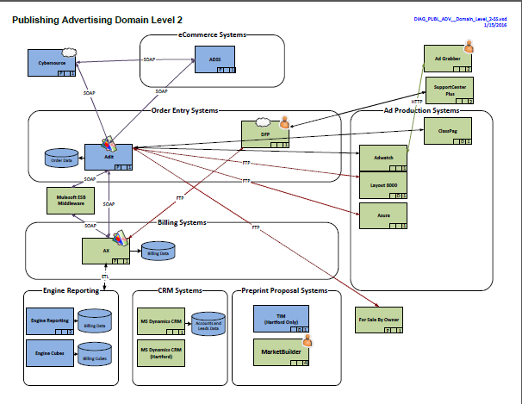

**Applications**

* MS Dynamics AX- Billing and Accounts Receivables
* ADIT- Order entry- custom .NET/Silverlight solution developed by LA development team
* CRM 2011- Customer relationship management
* MAS 200- New application that is used by some vendors, not considered as of now
* Future - ADIT 2, CRM 2013

**ADIT**

* Adit is a web based display Ad Order Entry Application.
* It allows users to enter orders for display, online and other form of advertising
* Order information entered in Adit is passed on to production, fulfilment, creative and
* Billing (AX), and reporting system. This application uses SQL server database.
* Interfaces with AX (billing application - part of engine

**AX**

* MS Dynamics AX is the Advertising billing system for the order entry system Adit.
* AX is an enterprise A/R stytem. AX is accessed by Citrix or Remote Desktop
* MorphX - Integrated dev environment (drag and drop, intellisense, forms, reports etc)
* X++ language - OOPs language, Garbage collection, Integrated SQL queries
* Interfaces with Adit (part of Engine), uses SQL Database

**CRM 2011**

* CRM is a Customer Relationship Management application. It is the ability for a company to capture key details about its customers. It is web based, uses SQL Database

**MAS 200**

* It is a very small billing application for syndication, contact with talent, magazines/
* They takes cartoons and content and charge fee based of contracts.
* Accessed by users via Citrix or Remote Desktop. Supported on the business side.
* EDXP programming language used in this application, uses SQL Database

**Application level interaction**

* Different environment for all the applications- Dev. QA, Stage, production also do the Burn down
* Incident management can be accessed through the below link:

[http://teams.tribune.com/technology/Toolbox/SM/KB/Pages/Incident Management - Home.aspx](http://teams.tribune.com/technology/Toolbox/SM/KB/Pages/Incident%20Management%20-%20Home.aspx)

**Approach**

* Mean time to repair (MTTR) is a basic measure of the maintainability of repairable items. It represents the average time required to repair a failed component or device.

**AdWatch**

* Tribune publishing's Content management (CMS) and Ads Fulfilment system for Retails and classified ads
* This application vendor is Mediaspectrum
* -Web interfaces, Oracle DB, NFS shares. Adwatch controls the processing
* Through SOAP (eBridge), JDBC and AdRouter calls.
* Application access by HTTP web interface
* Firefox version 3.6.9
* AdDrop and eProofs web integrated apps run on IE, Firefox and Chrome

**Typical users**

* Sales reps, Trafickers (CR), Ad Builders, Production (AdOps)
* Workflow - Adit orders, Electronic (camera only), pickups, pickup w.changes, spec ads
* Submitting material - AdDrop and Agensee
* Proofing - delivery of PDF via eProofs

**Maintenance**

* Daily or weekends
* Data base restarted once 90-180 days
* Occasionally security patches

**Change management**

* Major upgrades, changes on Dev. environment
* Upgradation and configuration changes are done on QA
* Keep related app in sync Prod to QA (AdWatch DB, fileShare)
* Prod upgrades and changes are managed by change management process
* Require business and technology approvals to proceed.

**Environments**

* Production, QA and DR (Disaster recovery) for custom build applications
  1. Standard Process to Follow
* Daily Task – AdIT Team
* Alerts
* Different reports
* Tickets(P1-P4) - break/fix issue
* Daily IT control valuation - required by Audit
* System monitoring

**Incident management**

Incident management is a critical process that provides organizations with the ability to first detect incidents and then to target the correct support resources in order to resolve the incidents as quickly as possible. The process also provides management with accurate information on the incidents affecting the organization so that they can identify the required support resources and plan for their provision.

By utilizing the incident management process and effectively handling major incidents, organizations can ensure that their support resources are focusing on the issues that have the greatest urgency and potentially the greatest impact on the business.

* P1- Escalated immediately -exceeded the 30 mins downtime rule
* P2- 15 min work towards a solution
* P3- we triage the ticket and have at least a day to address it.
* Generally product setup request and configuration changes
* P4- tickets that takes 2-4 weeks to address, product setup and configuration changes

**Change management**

Change Management is an important support function that all teams across technology must participate in. Following good practices with change management enables a higher success rate of implementation and lower number of major impacting events due to poorly planned changes. Understanding the change request process, and what needs to be covered in the end to end cycle of a change management helps us all follow the same standards.

**Different Types of changes**

* IT changes - Proactively planned, fully tested, plan schedule and approved, Reviewed and approve by release board
* Immediate changes- Highly responsive, fully tested, not enough time to review, Approved by technology manager
* Emergency changes - Highly responsive, Related to major impacting incidents p1 or p2, changes recorded can be logged after the change is implemented
* Maintenance changes - CR creation is required
* Proactively planned, fully documented in SOP, Considered pre- approved by release board

1. Operating Procedures

<Include a brief description of the Standard Operating Procedures (SOP) for each of the standard resolution procedures. Present this information as step-by-step instructions containing details such as the overview of the issue, procedure to resolve the same along with figures/screenshots.>

* 1. Overall Application Architecture

This procedure contains detailed information on the inputs required and the step-by-step instructions to execute the procedure, and the output.

Please refer advice document located at below path:

* <https://confluence.tribpub.com/pages/viewpage.action?spaceKey=PETS&title=Project+Engine+-+Tech+Space>

**Tools used**

* Jira – Bug tracking tool
* Jenkins – Application build configuration
* Service Manager – For Incident tracking
  + 1. Input/Entry criteria

<Include the input criteria that must be met before the steps/tasks can be executed>

<Sample text>

* User account exists on your organisation's messaging server.
* Search criteria for searching a user account.
  + 1. Steps/Tasks

<Include the step-by-step procedure>

<Most procedures consist of a number of steps. Try to limit a procedure to seven or fewer steps. Instructional design experts say this is the maximum number of items people can remember at once.>

<Multiple-step procedures:

* General rules for lists also apply to procedure lists — especially the following:
* Set individual steps as separate, numbered entries. However, short steps, if they occur in the same place (within one dialog box, for example), can be combined.
* Both of the following examples are correct, although the first is more commonly used.

Steps should be written in Location-> Action-> Result format

In this example:   
Location – Tools menu

Action – Click Options

Do not write Action and then Location like: Click Options on the Tools menu

Correct

1. On the Tools menu, click Options, and then click the Edit tab.  
   The *** appears.
2. …
3. On the Tools menu, click Options.
4. Click the Edit tab.

Do not number the system response (result)

The *** appears.

<Some pointers to look for while writing Procedures>

* Use the style Numbered list_1 to present procedures.
* Do not use a period following the step number unless your design requires it.
* Use complete sentences.
* Use parallel construction.
* Capitalise the first word in each step.
* Use a period after each step. An exception is when you are instructing users to type input that does not include end punctuation. In this case, try to format the text so the user input appears on a new line.
* In printed documentation, try to keep all steps in a procedure on one page. Online, keep a procedure to one screen.
* Avoid burying procedural information in narrative text; the procedure will be hard to find and follow.
* Avoid writing single step procedures.
* Break long procedures into smaller sub-procedures, if required. Include them within sub-headings as follows:

<Sample text>

You can add a user account to the BlackBerry Enterprise Server (BAS), assign a BlackBerry device to a user account and activate the BlackBerry device. The user account must exist on your organisation's messaging server.

* + 1. Output/Exit criteria

<Specify the expected output clearly.>

<Sample text>

User Account is created and added to the BlackBerry Enterprise Server and an e-mail is sent to the user by default.

1. Service Level Management

This section contains SLAs as agreed with the Customer and the corresponding metrics to quantify these SLAs.

* 1. Tower wise SLAs and Quantified Metrics

<Provide the tower wise Service Level Agreement (SLAs) and also their corresponding metrics to quantify.>

* 1. Tower wise OLAs and Quantified Metrics

<Provide the Operational Level Agreement (OLAs) and also their corresponding metrics to quantify, if required.>

1. Escalation Matrix

This section provides the service levels and matrix for escalation of issues.

* 1. Escalation Service Levels

<Provide service level matrix for escalation of issues. Include the escalation service level matrix for vendors in a separate table, where applicable. Specify information on time zones to be used depending on the Customer, for example, IST, EST, CST, BST and so on.>

<Sample text>

Table 3: Escalation Service Levels

| Service Level | SLA  (In hours) | Level 1  (In hours) | Level 2  (In hours) | Level 3  (In hours) | Level 4  (In hours) |
| --- | --- | --- | --- | --- | --- |
| S1 | 4.00 | 0.30 | 1.00 | 2.00 | 3.00 |
| S2 | 8.00 | 1.00 | 3.00 | 5.00 | 6.00 |
| S3 | 24.00 | 4.00 | 8.00 | 12.00 | 18.00 |
| S4 | 48.00 | 10.00 | 15.00 | 24.00 | 32.00 |

* 1. Escalation Matrix

<Include the escalation matrix with contact details in a table or a flow chart representation.>

1. Application Details

This section provides application level overview.

* 1. AdIT

The Adit! Order Entry System replaces the order entry function of the old Admarc system. Adit! allows users to enter orders for display, preprints, online, and other forms of advertising. Order information entered in Adit! is passed on to production, fulfilment, creative and billing (AX), and reporting systems. Adit is Tribune Publishing's centralized print order entry system. As part of the Admarc Replacement Project, Adit! is designed as a one-stop order entry system for display, preprints, online, special events/sponsorships and bundled advertising products. In addition to creating orders, Adit! passes order information to fulfilment, billing and reporting systems. The system replaces AIMS, and once the phased-in introduction is complete, Adit! will be the single-source for order entry across Tribune business units.

Adit! Features:

* Entry and management of orders, quotes and reservations
* Ad positioning and scheduling
* Product setup and management
* Pricing setup and management
* Contract setup and management
* Credit card payment interface for prepaid customers
* Reports (in development)

.

**Key Technologies**

* Microsoft .NET 4.0
* Microsoft Silverlight 4.0
* PRISM framework
* Microsoft Windows Communication Framework
* Microsoft SQL Server 2012
  + 1. Business Process Flow

There are different modules associated with ADIT, which are roles specific. The module won’t appear if not associated with the current role the user have. A user can have multiple roles but the higher role takes the precedence. The modules are listed below with their sub-modules.

**Order**

Under order we have the following sub-modules.

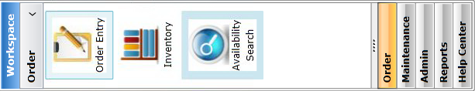

Order Entry – This is the most used module. This module is used to create new order, quote, and reservation. For creating new order, we need to create or assign customer to an order. We need to fill the order form, pricing. For display, classified as well as digital services has to be booked or created from this order.

Inventory – This module is used for inventory management. User can reserve space for their ad in any of the product of Tribune. Those inventory management done from this module.

Availability Search – User can search for space for their ad from this module. There are different search criteria provide for search namely BU (Business Unit), Product Type, Product, Ad Type, Section, Ad Size, Ad Label, From Date, Thru Date, Day of Week.

**Maintenance**

Under maintenance we have the following sub-modules.

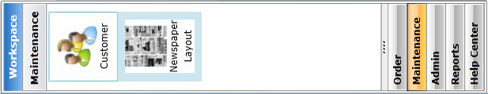

Customer – Customer management is done using this module. Existing customer information can be edited, new customer can be added. New customer creation happens in two ways. One can create customer information in ADIT that flows down into the downstream application for sync. The other way is Adding new customer information from AX into ADIT db.

Newspaper Layout – Every newspaper page layout can be modified from this module. New page can be added or deleted from/to any product. This activity is basically done by few selected executive of Tribune. Templates to be edited can be search using the search filter provided in the module.

**Admin**

Under admin we have the following sub-modules.

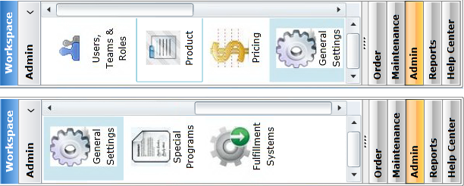

User, Teams & Roles – This module helps in managing the user along with their team and roles. User can be associated with multiple BU but among those BU one unit has to be selected as primary. User can view/edit their team along with team member associated with. Roles and their rights can be viewed/edited as well.

Product – New product can be added into ADIT using this module. This module is also useful for setting up any product level information, form etc. Any change to the forms or attributes can be applied at the product level from this module. Using BU and their respective service, one can drill down to product and can change attributes, form fields etc.

Pricing – This is the most complex module when it comes to modify pricing of any product. Using the same approach mentioned above one can drill down to the product. There are several factor listed against product to modify pricing of any type of ad. Depending on the factors listed, base price of any ad get changed when actual pricing of an order is calculated.

General Settings – This setting are global settings which can be overridden in the product level which in turn can be overridden in the section level. These setting are applied across all BU products.

Special Programs – This module is used to create some special program for any customer. The special program can be a contract, promotion, and coupon.

Fulfilment Systems – This module is of utmost important. Here we can create or add or delete rules that monitors the content flow from ADIT to downstream application.

**Reports**

Under reports we have the following sub-modules.

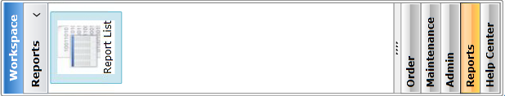

Report List – This module are loaded with pre-defined reports. It pulled data from AX to generate the report clicked.

**Help center**

Under help centre we have the following sub-modules.

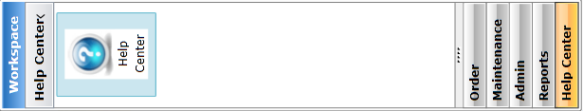

Help Center – This module is loaded with PDFs containing information on different ADIT module which helps user in performing ADIT functionalities smoothly. Training material can be accessed through online as well.

* + 1. Interfaces

Adit has both inbound and outbound system associated with it.

The inbound (Upstream) systems are:

**AdSS (Advertising self-service)** - Web portal for customer to book and add their own ads

**CSC (Customer service coordinator)** - Order entry system for display ads

**MDM (Master data management) Profisee** - One master data for each advertiser

**Melissa Data** - It is used for customer address verification

**Orchard B2B marketing** - Used for placing an order online (Personalise online ads)

**Cyber source** - Used for credit card processing in Engine

The outbound (Downstream) systems is:

**AdWatch** - Takes adIT ads booking, product section addition and matches with metadata. It contain size and block of the ad.

* + 1. Databases

**Database information**

|  |  |  |  |  |
| --- | --- | --- | --- | --- |
| **Instance** | **Server(s)** | **URL(s)** | **Database** | **Notes** |
| STAGE | FCWSOEWEB01 FCWSOEWEB02 | <http://fcwsoeweb01.usa.tribune.com/>  <http://aditstage.tribune.com/> | FCWSDYNSQL01\bookit_stage | Staging instance. Used for UAT testing. This is the version that gets promoted to PROD in a production deployment. |
| QA | TTWQOEWEB01  TTWQOEWEB02  TTWQOEWEB03 | <http://ttwqoeweb.tribune.com/>  <http://aditqa.tribune.com/>  <http://aditqa2.tribune.com/> | FCWQINDYNSQL01\bookit_qa | QA instance of Adit. This is deployed by the Jenkins job "Adit QA", and must be invoked manually. This is the instance that is used for QA and regression testing. |
| PROD | TTWPOEWEB01  TTWPOEWEB02  TTWPOEWEB03 | <http://adit.tribune.com/> | FCWPINDYNSQL\bookit | Production instance of Adit. |
| DEV | TTWDOEWEB01 | <http://ttwdoeweb01.usa.tribune.com:9000/> | FCWDINDYNSQL01\bookit_dev | Development instance of Adit. This is deployed nightly via an automated Jenkins job. This is the "current working" DEV version. |

**Additional database**

|  |  |
| --- | --- |
| **Database** | **Notes** |
| FCWDINDYNSQL01\bookit | This is a daily copy of the production database (previous day's backup). This can be used to run queries of "production" data if they don't need to include the current day's changes. |
| FCWQINDYNSQL01\CodeMapping | QA code mapping database |
| FCWPINDYNSQL\CodeMapping | PROD code mapping database |

**File locations**

|  |  |
| --- | --- |
| **Location** | **Path** |
| Adit QA Web Services | \\ttwqoeweb01\d$\webservices |
| Adit QA Web Sites | \\ttwqoeweb01\d$\websites |
| Adit PROD Web Services | \\ttwpoeweb01\webservices |
| Adit PROD Web Sites | \\ttwpoeweb01\websites |
| Adit PROD downstream processing files  (temporary files generated when sending  data to downstream systems) | \\ttwpdynapp04\Transform |
| ClassPag report files  (used by AditETearsheets program) | \\FCWPDYNFT01\Engine\ETSDrop |

* + 1. Dependencies

The Applications Impacted by the Solution

|  |  |  |  |  |
| --- | --- | --- | --- | --- |
| **ID** | **App Name** | **Description** | **SOX Impact** | **Note** |
| |  | | --- | |  |   1 | |  | | --- | | Microsoft Dynamics AX | | Integrations to create and lookup customers as well as submit orders for billing. |  |  |
| 2 | |  |  | | --- | --- | | ADP |  | | Integration to submit orders for ad production |  |  |
| 3 | APR | Integration to submit orders for ad production |  |  |
| 4 | Layout 8000 | Integration to submit ads for layout allocation |  |  |
| 5 | CECS | Integrates to Adit's Order Gateway service to submit billing records to AX. |  |  |
| 6 | DASS | Integrates to Adit's Order Gateway service to submit billing records to AX |  |  |
| 7 | |  |  | | --- | --- | | Advision |  | | Integrates to Adit's Order Gateway service to submit billing records to AX |  |  |
| 8 | ADS | Integrates to Adit's Order Gateway service to submit billing records to AX. |  |  |

* + 1. Operating Assumptions

As previously mentioned, application logic in Adit resides in various services, portioned logically

* **Product:** Handles maintenance and lookup of products.
* **Pricing:** Handles rules maintenance and procedures used in pricing
* **Order:** Handles creation, updates and cancellations of orders, quotes and reservations
* **Special Programs:** Handles creation and updates of contracts and promotions
* **General Settings:** Handles maintenance of system settings
* **User:** Handles maintenance of user roles, rights, business unit and team membership
* **Draw:** Handles upload and browsing of draw footprints
* **Customer:** Handles creation and updates of customer data.
  + 1. Minimum Hardware and Software Requirements

The following prerequisite software and configuration is required in order to build the project:

* Visual Studio 2012 Professional/Premium/Enterprise
* Silverlight 4 SDK (<https://www.microsoft.com/en-us/download/details.aspx?id=7335>)
* Silverlight 4 toolkit (<https://silverlight.codeplex.com/releases/view/43528>)
* Telerik Silverlight Controls (<file://FCWDADITAPP01/SoftwareInstallFiles>/RadControls_for_Silverlight_4_2011_1_0419_Dev.msi)
* Microsoft Report Viewer component ((file://FCWDADITAPP01/SoftwareInstallFiles/ReportViewer.exe)
* Entity Framework Power Tools (install using NuGet package manager)
* A SubVersion client and/or Visual Studio Plugin:
* (recommended) Visual SVN (must use version 3.53 for the license key below): <https://www.visualsvn.com/files/VisualSVN-3.5.3.msi>
* TortoiseSVN: <https://tortoisesvn.net/>
* Ankh SVN: <https://ankhsvn.open.collab.net/>

The full Adit source code (including Adit 2.0) is located here:   
<https://svn.tribune.com/Windows/BookIt/trunk>

* + 1. Inventory

There is a Jenkins job set up to pull the access list daily from SVN and email the list to IT Compliance, JenkinsAdmin, Karen Jennings and Mehrnaz Sadolahy.

Jenkins job:

<http://jenkins.tribune.com/job/SVN%20Access%20File%20-%20IT%20Compliance/>

Job runs daily around midnight CDT.

Script to pull the list:

#!/bin/bash

scp maherrera@lalpsvnweb01.usa.tribune.com:/usr/local/apache2/conf/conf.d/svn_access_file "${WORKSPACE}/svn_access_file-$(date +%Y%m%d).txt"

Rights to edit this Jenkins job:

JenkinsAdmin

Mehrnaz Sadolahy

1. To check the access list:

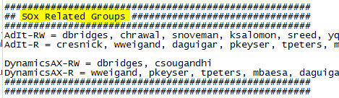

1. Search for group “AdIt-RW”, verify that all members are in SDD org. Membership to this group can be verified in the Global Address book in Outlook.

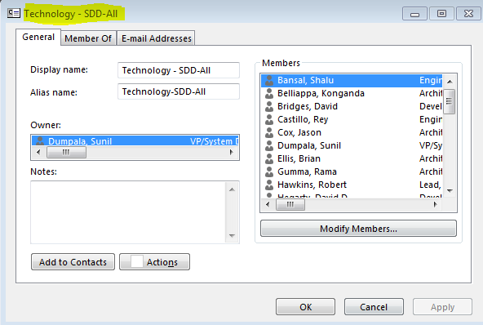

1. Search for group "Adit - R", verify all members are in Operations (Support).

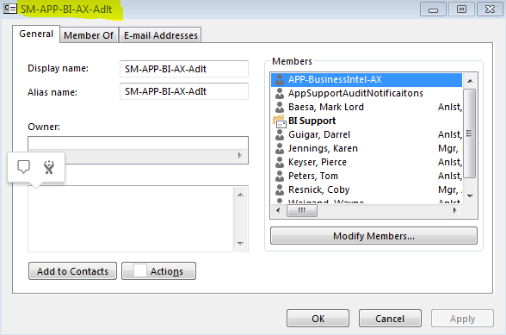

If everything is in order you would mark the following Controls in the SOx Weekly list as Compliant:

PM 2.1 - Access to development and test libraries is restricted to authorized IT personnel [**See this document for instructions.**](https://confluence.tribpub.com/display/RM/Adit+SVN+Access+List) Application ADIT

This is the spreadsheet:

<http://teams.tribune.com/technology/ops/AppSup/Lists/SOX%20%20Daily%20Validation/Allitemsg.aspx> (Also available in Citrix as "SOx Daily Checks." We used to have to do this every day now it is weekly and must be completed by 3:30pm CDT on Friday.

Filter for Release Manager Name under "Week ending MM/DD Validator #2"

Mark the PM 2.1 Control as Compliant by selecting Compliant from the drop down.

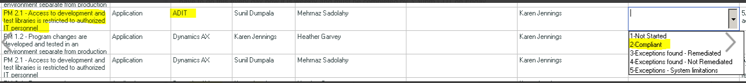

If everything is NOT in order you will need to mark the Control as an Exception. If steps have been taken to remediate the exception (request submitted to remove the user) then you can note Exceptions found - Remediated. If for some reason you cannot remediate the Exception, you would select Exceptions found - Not Remediated. Exceptions - System limitations would be selected if the system would not allow us to implement this control. It would not apply here.

All Exceptions or Blank Statuses will be discussed in the **MANDATORY - Weekly SOX checkpoint meeting**. Control owner or validator must explain any Exceptions.

* + 1. Security Requirements

**External System Interface Designs**

Adit will initially expose the following external system interfaces:

* Order Gateway: Provides ordering and lookup capabilities for external systems
* Product Gateway: Provides product and pricing lookup for external systems
* Customer Gateway: Provides customer lookup/creation for external systems

**Availability and Reliability Designs**

* Web service interfaces are deployed in an NLB environment, where if a machine dies or reaches capacity, another machine will assume the load.
* AX web service interfaces are deployed in an NLB environment, where if a machine dies or reaches capacity, another machine will assume the load.

**Performance and Capacity Designs**

* Anticipated load on the system is up to 120 concurrent users.
* Anticipated load testing may go up to 250 concurrent users.

**Security Designs**

* Initial user level security will be based on ASP.NET roles unitl a suitable enterprise security solution is identified
* Web services will be configured to run under a service account, requiring authentication prior to use.

All modules in the Adit platform need to reside on a web server. Silverlight modules reside on the web server, but are downloaded to the client machine and executed locally. Initally, all web services can reside on web balanced web servers. Should certain web services become more prone to high concurrency or demand more resources, they can be scaled out to their own web servers. Intially, the infrastructure would be configured as such:

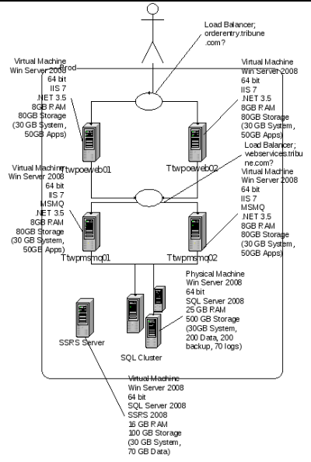

* + 1. Environments

This section provides the environment details with respect to the Adit.

**This is a list of the distinct environments for Engine**

|  |  |  |  |  |  |
| --- | --- | --- | --- | --- | --- |
| **Name** | **SQL Server** | **AX DB Name** | **Adit DB Name** | **Adit URL** | **AIF URL** |
| Dev | FCWDINDYNSQL01 | AX_Tribune_dev1 | bookit_dev | <http://ttwdoeweb01.usa.tribune.com:9000/> | <http://ttwdmsmq01.usa.tribune.com:83/MicrosoftDynamicsAXAif50/> |
| QA | FCWQINDYNSQL01 | AX_Tribune_QA1 | bookit_QA | <http://ttwqoeweb.tribune.com/> | <http://ttwqmsmq.tribune.com/MicrosoftDynamicsAXAif50/> |
| Setup | FCWDINDYNSQL01 | AX_tribune_setup | bookit_setup | <http://fcwqoewebla01.usa.tribune.com:9000/> | <http://fcwqmsmqla01.usa.tribune.com/MicrosoftDynamicsAXAif50/> |
| Conversion | FCWDINDYNSQL01 | AX_Tribune_cnv1 | bookit_cnv1 | <http://ttwcoeweb01.usa.tribune.com:9000/> | <http://ttwcmsmq01.usa.tribune.com/MicrosoftDynamicsAXAif50/> |
| Performance | FCWTINDYNSQL01 | AX_Tribune_perf | bookit_perf | <http://fcwtpoeweb.tribune.com/> | <http://fcwtpmsmq.tribune.com/MicrosoftDynamicsAXAif50/> |
| Staging | FCWSINDYNSQL01 | AX_Tribune_stage | bookit_stage | <http://fcwsoeweb01.usa.tribune.com/> | <http://fcwsmsmq01.usa.tribune.com/MicrosoftDynamicsAXAif50/> |
| Production | FCWPINDYNSQL | AX_tribune_prod | bookit | <http://adit.tribune.com/> | <http://axaif.tribune.com/MicrosoftDynamicsAXAif50/> |
| Disaster Recovery | LAWRDYNSQL | AX_tribune_prod | bookit |  |  |

These are the current developer VM assignments. Note: The previous user is listed in parentheses.

|  |  |  |  |
| --- | --- | --- | --- |
| **VM** | **Assigned to** | **C drive** | **Comments** |
| FCWDDYNTST01 | Open (Santosh) |  | AX 2012 |
| FCWDDYNTST02 | Massoud |  | AX 2012, 3 drives |
| TTWDDYNTST01 | Paul Mayle | 300 |  |
| TTWDDYNTST02 | Santosh (Old) | 300 | O/S R2, Tribune AX, SQL 2012 |
| TTWDDYNTST03 | AX 2009 Out of box (No Trib Code) | 300 |  |
| TTWDDYNTST04 | Kevin | 300 |  |
| TTWDDYNTST05 | Open (Bill) | 300 |  |
| TTWDDYNTST06 | Open (Mazik #1) | 300 | Reserve |
| TTWDDYNTST07 | Massoud | 300 |  |
| TTWDDYNTST08 | DSI | 300 |  |
| TTWDDYNTST09 | Kavita (Madhavi) | 300 |  |
| TTWDDYNTST10 | Operations Support | 75 |  |
| TTWDDYNTST11 | Open (Masik #2) | 300 | Reserve |
| TTWDDYNTST12 | Santosh (New) |  |  |

App system details along with server name, server type, IP address are located at: [server details](https://confluence.tribpub.com/display/PETS/Engine+Environments)

* + 1. Development

|  |  |  |  |  |  |
| --- | --- | --- | --- | --- | --- |
| **Name** | **SQL Server** | **AX DB Name** | **Adit DB Name** | **Adit URL** | **AIF URL** |
| Dev | FCWDINDYNSQL01 | AX_Tribune_dev1 | bookit_dev | <http://ttwdoeweb01.usa.tribune.com:9000/> | <http://ttwdmsmq01.usa.tribune.com:83/MicrosoftDynamicsAXAif50/> |

* + 1. Test

**Adit Smoke Testing in Non-Prod Environment**

For Non Prod environment - Please refer the link for Smoke test Template - [Adit QA Smoke test](http://teams.tribune.com/projects/Project%20Engine/_layouts/xlviewer.aspx?id=/projects/Project%20Engine/Project%20Documents/Quality%20Assurance%20(QA)/Adit/Templates/Adit%20QA%20Smoke%20test.xlsx&Source=http%3A%2F%2Fteams%2Etribune%2Ecom%2Fprojects%2FProject%2520Engine%2FProject%2520Documents%2FForms%2FAllItems%2Easpx%3FRootFolder%3D%252Fprojects%252FProject%2520Engine%252FProject%2520Documents%252FQuality%2520Assurance%2520%2528QA%2529%252FAdit%252FTemplates&DefaultItemOpen=1&DefaultItemOpen=1)

**Adit Smoke Testing in Prod Environment**

* ADIT Smoke testing is done for all the BUs using combination of Automation and Manual test cases. Smoke test results are uploaded in SharePoint.

Please refer the attached smoke test results for latest sprint for more details: [Sprint 94 Production Smoke Test](http://teams.tribune.com/projects/Project%20Engine/Project%20Documents/Quality%20Assurance%20(QA)/Adit/Sprint%20Documents/Sprint94/Sprint%2094%20Production%20Smoke%20Test.xlsx)

* Once Smoke testing is completed, QA team sends emails to all the Business Units for downstream validation of all those orders.
* Once QA receives the confirmation from downstream systems, Orders are killed from Adit Prod and again Order Kills are confirmed with downstream systems.

**Adit downstream intergration testing**

ADSS and ADIT testing involves downstream integration testing

* For Login or Registration, ADSS uses SSOR feature.
* For Credit card Payment validation, ADSS and ADIT uses cybersource - <https://ebctest.cybersource.com/ebctest/login/Logout.do>
* For Adwatch and Layout - Using the FTP Server and login details, validate xmls. Sometimes QA also needs to validate the Admaterials in Adwatch application
* For AX - Remote login into [ttwddynapp01.usa.tribune.com](http://ttwddynapp01.usa.tribune.com) using AD login details
* CheetahMail Templates - for any issues or new configuration, QA team reaches out to Lewis/Marnie from Business team
* AdPay - \\ttwqoeweb01\temp\AdPay
  + 1. Test Scenarios

**Functional testing involves feature testing including validation in downstream systems.**

The Test Results are attached in the QA subtask of each JIRA that requires QA testing/functional testing, for test case/test results format please refer JIRA

* Validating data in database - FCWQINDYNSQL01\bookit_qa
* In case of any errors, validating the Error Log files in web servers : FCWQADSWEB01.[usa.tribune.com](http://usa.tribune.com) , FCWQADSWEB02.[usa.tribune.com](http://usa.tribune.com)
* Validating WebServices - \\ttwqoeweb01\d$\webservices
* Validating downstream integrations with AX, Classpag, Cybersource, Adwatch, Adpay, etc.
* Running job scheduler - <http://ttwqoeweb01:8080/schedule.aspx>

In case of Orders going into Error, please refer the activity Logs from <http://lalink.tribpub.com/adit/activity.aspx>

* + 1. User Acceptance Test

UAT contains all 3 type of testing mentioned above in the test section

* Adit Smoke Testing in Non-Prod Environment
* Adit Smoke Testing in Prod Environment
* Adit downstream intergration testing
* Adit functional testing
  + 1. Production

­Production environment is given in the screenshot below:

|  |  |  |
| --- | --- | --- |
| **Application Name** | **Server Name** | **IP Address** |
| Adit Production | TTWPOEWEB01 | 10.161.82.23 |
| Adit Production | TTWPOEWEB02 | 10.161.82.24 |
| Adit Production | TTWPOEWEB03 | 10.161.82.25 |

* + 1. Deployment Procedure

**1.0: Move logs Files on fcwSoeweb01 and fcwSoeweb02**

**Run from --> \**\fcwpoesched01\D$\Jenkins\Adit_UAT_scripts\Automated_Deployment

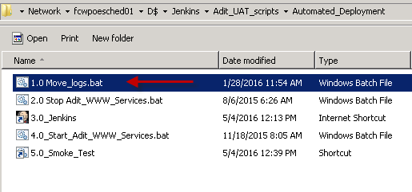

Type U and press Enter at prompts to move/delete log files.





Server free space is listed upon completion:

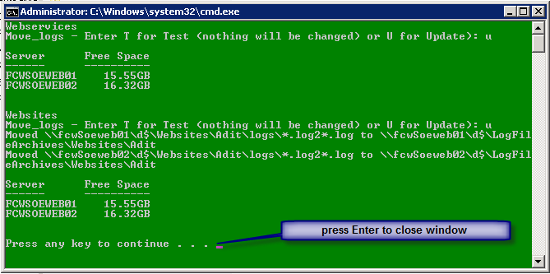

**2.0: Stop WWW services on fcwSoeweb01, fcwSoeweb02**

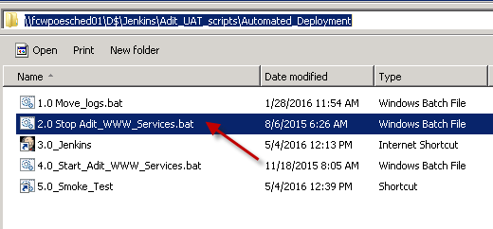

Type STOP and press Enter to stop Running services.

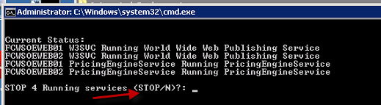

Window background will turn GREEN if all services are stopped successfully and RED if there was a problem. Press Enter to close the window. If a failure occurred, Stop “Dynamics AX Object Server 5.0$01” on all servers manually using services.msc.

**3.0: Jenkins Build (**[**http://jenkins.tribune.com/**](http://jenkins.tribune.com/)**)**

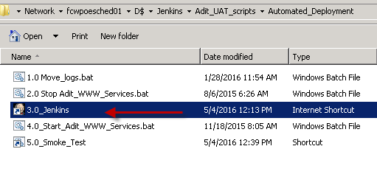

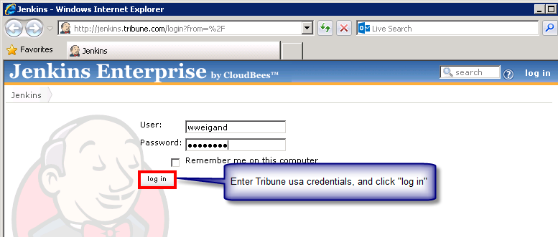

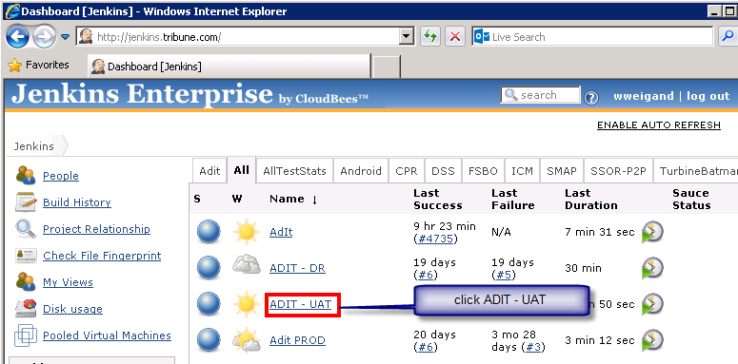

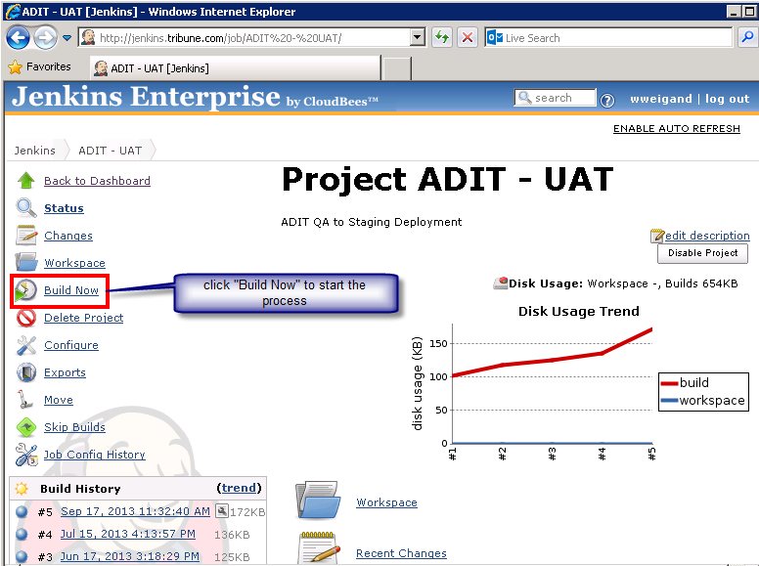

After the build begins, a new entry will appear under “Build History”. Move the cursor over the new entry and click “Console Output” to view the Build progress.

If message **(pending – fcwpoesched01 is offlne)** appears under “Build History”, verify that service “Jenkins Slave” is started on fcwPoesched01.

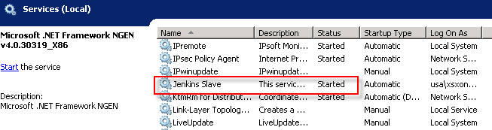

Jenkins “Console Output” lists SUCCESS / FAILURE on the last line:

Finished: SUCCESS indicates all is well and WWW services can be restarted once all deployment activity is complete (sql script execution …).

Finished: FAILURE indicates a problem. Check previous lines in “Console Output” to determine where the failure occurred and continue using the appropriate “Manual Deployment” steps.

Logs are created in \\fcwSoeweb01\d$\ops\logs.

**4.0: Start WWW services on fcwSoeweb01, fcwSoeweb02**

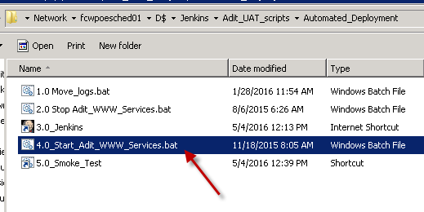

Type Y and press Enter when prompt “START 3 Stopped services (Y/N)?" appears.

Window background will turn GREEN if all services are started successfully and RED if there was a problem. Press Enter to close the window. If a failure occurred, Start “World Wide Web Publishing Service” on all servers manually using services.msc.

**5.0: Smoke Test**

Click to run UAT ADit Smoke Test

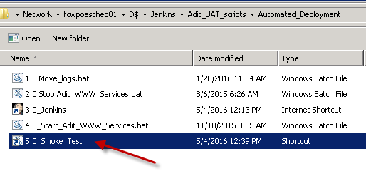

Manual Deployment instruction - **Run From \\fcwpoesched01\D$\Jenkins\Adit_UAT_scripts**

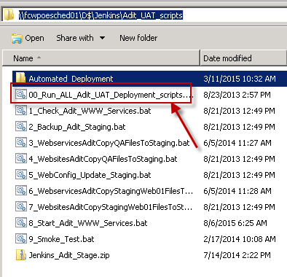

Double click “00_Run_ALL_Adit_UAT_Deployment_scripts” to run Manual Deployment scripts sequentially. All scripts except “8_Start_Adit_WWW_Services” will be run. Window background will turn GREEN if a step was successful and RED if there was a problem. Press Enter to close the window.

If there is a problem with any script, subsequent scripts can be run one at a time to compete the deployment. Each step can be run by double clicking. Window background will turn GREEN if a step was successful and RED if there was a problem. Press Enter to close the window.

Logs are created in \\fcwSoeweb01\d$\ops\logs.

Double click “8_Start_Adit_WWW_Services” after all other deployment activities (dba scripts …) have been completed.

Same procedure will apply for QA and Production environment

* 1. AdWatch

Tribune publishing’s Content Management (CMS) and Ad fulfilment System for Retail and Classified Ads. The application vendor is Mediaspectrum

* Ad orders are delivered from Adit via XML
* Ads are tracked through various stages of the ad building process until the ad is finalized and delivered to the downstream publishing systems.
* Data is managed through Web interfaces, Oracle DB and NFS shares. AdWatch controls the processing through SOAP (eBridge), JDBC and AdRouter calls. JAVA based application.
* Application access is via HTTP Web interface on Macs for Ad Building using AdWatch EX with application plug-ins for Adobe InDesign and Awex extensions that allow the application to interact with the Firefox browser. Dependent on older FF version 3.6.9 to function properly. (Windows PCs can be used for other access outside of Ad Building)
* AdDrop and eProofs Web integrated apps, run on IE, FF, Safari, Chrome.
* Web Admin (User and Application Management Tool)

**Key Application Components**

* AdWatch EX
* AdRouter
* AdDrop/eProofs
* IMQ
* Web Admin
* Firefox (3.6.9)
* Adobe InDesign (5.5)

**Key Infrastructure Components**

* WAS Servers (IBM Websphere Application Server v6 on CentOS Linux VM)
* AdRouters (Linux CentOS VM)
* Database (Oracle DB 11g) RHEL on UCS bare metal blades
* Network Load Balancing (F5)
* Web/App servers (Apache/TomCat) on Cent OS Linux VM
* NetApp NFS 12tb, EMC VNX (DB) 2tb.
  + 1. Business Process Flow
       1. WebAdmin
* Web Admin – Consists of several user interfaces that allows those with Administrator rights the ability to set up.
* AdDrop
* EProofs
* Product Setup
* System Admin
* System Translator

**AdDrop – Ad/Component Uploading**

* AdDrop allows a customer or sales rep to upload ad components or completed ads from a browser. When a booking order arrives in AdWatch, an email is sent to the customer with an AdDrop URL.

AdDrop URLs -

* <http://upload.baltimoresun.com/addrop/>
* <http://upload.sun-sentinel.com/addrop/>
* <http://upload.orlandosentinel.com/addrop/>
* <http://upload.mcall.com/addrop/>
* <http://upload.courant.com/addrop/>
* <http://upload.dailypress.com/addrop/>
* [http://upload.sandiegouniontribune.com/addrop/](http://upload.sandiegouniontribune.com/addrop/controller?queue=sd_art)
* <http://upload.chicagotribune.com/addrop/>
* <http://upload.latimes.com/addrop/>

AdDrop configuration

* Each business has its own look.
* Localization configuration - /opt/mediaspectrum/localization/addrop
* AdDrop URL needs to match configuration in ebridge.prop.
* So, cannot access IP address unless defined in ebridge.prop.
* Actual website located in /opt/mediaspectrum/localization/addrop/upload*com
* Sales rep and publication lists populated nightly at 10:45pm Central time by 52apr-addroplists.xml adrouter.
* Sales rep list - /opt/mediaspectrum/localization/addrop/upload*com/{bu}_[art|pdf]/xmllist/account_representative-values.xml
* e.g. /opt/mediaspectrum/localization/addrop/upload-la_tribdev_com/la_art/xmllist/account_representative-values.xml
* Publication list - /opt/mediaspectrum/localization/addrop/upload*com/{bu}_[art|pdf]/xmllist/ad_publication-values.xml
* e.g. /opt/mediaspectrum/localization/addrop/upload-ct_tribdev_com /ct_pdf/xmllist/ad_publication-values.xml
* Messaging - /opt/mediaspectrum/localization/addrop/global.prop (our own enhancement).

**eProof**

* Provides online markup of pickup with changes and proofing of completed ads. Customers/Sales Reps receive an email notification when an ad is ready for markup (pickup with changes) or for proof.

**eProof URLs**

* <https://ads.baltimoresun.com/eproofs/>
* <https://ads.chicagotribune.com/eproofs/login.jsp>
* <https://ads.orlandosentinel.com/eproofs/>
* <https://ads.mcall.com/eproofs/>
* <https://ads.courant.com/eproofs/>
* <https://ads.dailypress.com/eproofs/>
* <https://ads.latimes.com/eproofs/>
* <https://ads.sandiegouniontribune.com/eproofs/>
* <http://ads.sun-sentinel.com/eproofs/>

**eProofs configuration**

* Unlike AdDrop, eProofs can be accessed via DNS name or IP address.
* Localization configuration - /opt/mediaspectrum/localization/eproofs.
* Messaging - /opt/mediaspectrum/localization/eproofs/global.prop (our own enhancement).

**Product Setup**

* This is where you set up items like Ad Types, Column Definitions, Deadlines, Editions, Page Types, Placements, Positions, Products, Size Units and Editions.

**System Admin**

* This is where you set up items Users and Order Sources.

**System Translator**

* This is where we translate new Product & System items to the various markets.
  + - 1. AdRouters
* A Dispatch Daemon, it scans objects to be processed based on a pre-determined interval
* It executes business logics by invoking processing commands
* It is utilized for integrating with external systems
* Ad routers move files in, out and around the AdWatchEX system

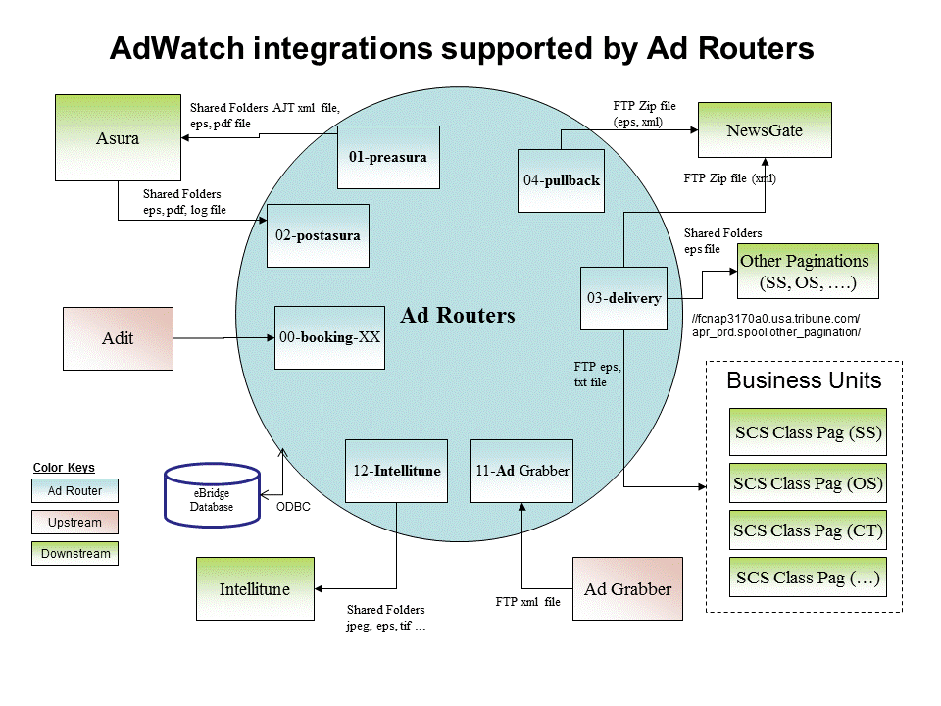

**Expire Archive Purge Adrouters**

* The cleanup of AdWatch data is split into 3 phases, expire, archive, and purge. Expire phase is contained in 20apr-expire.xml. Archive and purge phases are contained in 21apr-archive-purge.xml.

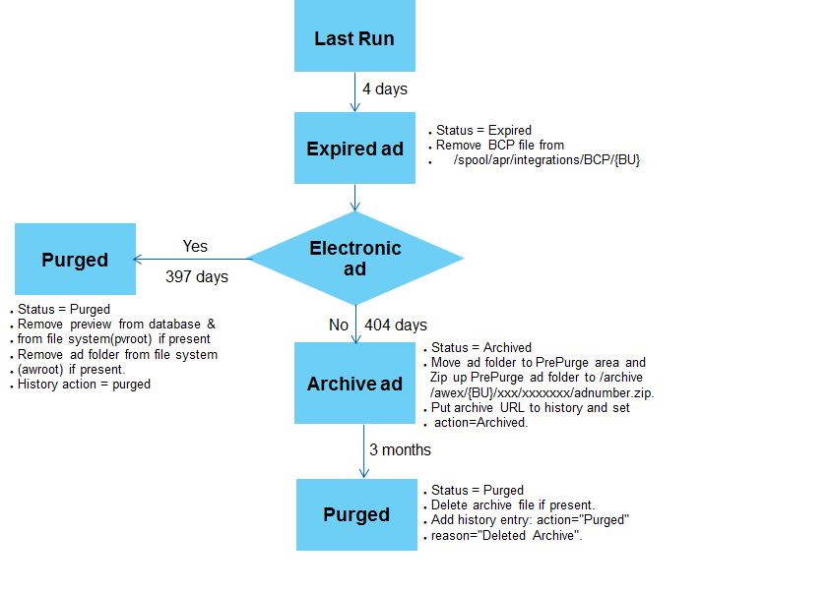

* + 1. Interfaces
* Typical Users – Sales Reps, Traffickers, Ad Builders, Production (AdOps)
* Workflow – Adit Order, Electronic (Camera ready), Build Ads, pickups, pickup w/changes. Spec Ads built internally without Ad order from Adit.
* Submitting Materials (Components) AdDrop and Agensee
* Proofing – delivery of PDF via eProofs to review corrections, perform mark up (revises) for Ad Builders
* Ad Building process – once Ad in Build state, Ad builder (designer) picks up the ad and builds.
* Finalized ads are sent to downstream systems, i.e Newsgate or ClassPag or other pagination workflows via AdRoutercalls.

**Maintenance**

* Daily and on weekends. System is up 23.5 hours daily. Half hour reboot of the WAS environment.
* Database is restarted once every 90-180 days
* Occasional Security patches
  + 1. Databases

**AdWatch DEV and QA environment**

|  |  |  |  |  |  |  |
| --- | --- | --- | --- | --- | --- | --- |
| **Server** | **Operating System** | **Oracle SID** | **Oracle version** | **Schema** | **Description1** | **Description2** |
| fclqaprdb01.usa.tribune.com | Linux CentOS | ADWATCHQ | 10.2.0.4.0 | DEVADWATCH | Development schema | Oracle database standard edition |
| fclqaprdb01.usa.tribune.com | Linux CentOS | ADWATCHQ | 10.2.0.4.0 | QAADWATCH | Quality schema | Oracle database standard edition |
| Adwatchqadb.usa.tribune.com | Solaris 10 | ADWATCHQ | 10.2.0.4.0 | ADWATCH1 | Quality schema | Oracle database enterprise edition(created 9-26-2011) |

**AdWatch prod environments**

|  |  |  |  |  |  |  |
| --- | --- | --- | --- | --- | --- | --- |
| **Host Name** | **Operating System** | **Oracle SID** | **Product version** | **UNIX login** | **Comment1** | **Comment2** |
| ttusc-zone4.latimes.com | Solaris10 | ADWATCH | 10.2.0.4.0 | Oracle | Source DB | Oracle user adwatch1 |
| ttusc-zone4.latimes.com | Solaris10 | ADWATCH | 10.2.0.3.0 | Oracle | Source DB(Not in use) | EDB oracle user edb_adwatch84 |
| fclpentrepdb01.usa.tribune.com | Linux CentOS | N/A | EDB AS 8.4 | enterprisedb | Production postgres replication server | EDB postgres replication user entrprisedb(not in use) |
| fclpentrepdb01.usa.tribune.com | Linux CentOS | N/A | EDB AS 8.4 | enterprisedb | Target DB(not in use) | Edb-psql db_adwatch edb_adwatch84 |

* + 1. Dependencies

Upstream and downstream dependencies

**Integrations**

* Upstream – Adit/Adss
* Downstream – Layout 8000 LoRes Img, ClassPag, Newsgate, Intellitune (Image Toning), Asura (Preflighting) and external pagination workflows.
* Other: Agensee, AdWatch Reports, ePrefs

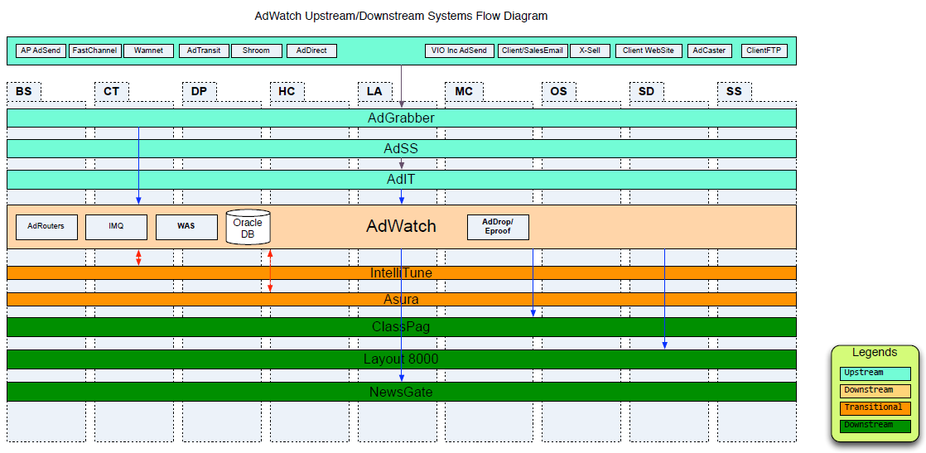

* + 1. Operating Assumptions
* The following workflow illustrates the operating overview of AdWatch:

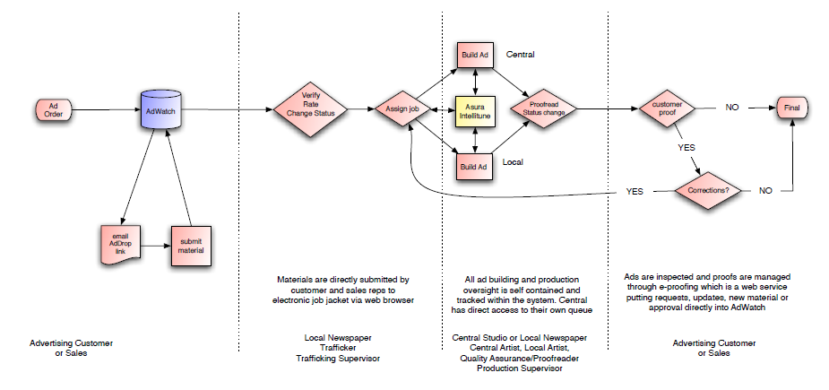

* + 1. Minimum Software Requirements

**AdWatch Macintosh Setup**

* NOTE: Any new Macintosh that is setup in the studio is cloned from a master. Onsite/desktop support is responsible to this operation.
* OS requirements tested and approved is Mac OS X Lion (version 10.7.5 )

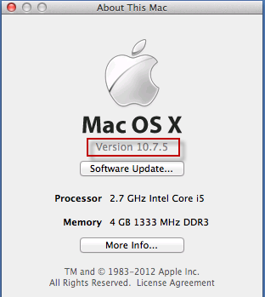

* Mac AdWatch Specified Software requirement :
* Adobe Creative Suite 5.5 (print version) should include
  + Adobe Illustrator – is a vector graphics editor geared towards print publications
  + Adobe InDesign – is a desktop publishing application
  + Adobe Photoshop – is a raster graphics editor. Geared towards editing and retouching digital photos.
  + Adobe Bridge – is an image organizer. Integrates with Adobe apps but has no editing capabilities of its own.
  + Adobe Acrobat – creates, edits and manages documents PDF
  + Microsoft Office
* Google Chrome (for Tribune Workday. Safari not compatible)
* Fire Fox 3.69 (for AdWatch application)
* Drag to application folder and rename it as follows: Firefox_3-6-9 this naming convention allows for Fire Fox to be excluded from McAfee antivirus software

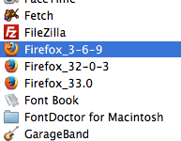

* Fonts
  + NOTE: The following business units use Universal Type Client (UTC) to manage and load fonts from the server: OS, SS, and BS. San Diego has their own version of Universal Type Client server and the rest of the remaining sites (LA, CT, MC, DP, and HC) load fonts locally.
  + System Library Fonts are customized for the sites running UTC only the essentials fonts are loaded.

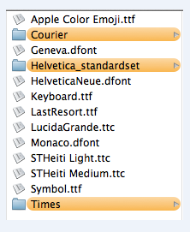

* + The main Library Fonts, which are used for applications (Microsoft office), need MT extra and Ariel.

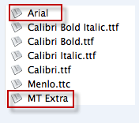

* Network
  + NOTE: all new Macs are bonded to the USA domain. But, do not login to the domain. They all use a generic user called “prepress” to the local machine.
    1. Inventory

Access mac mini for remote access

* Requirements:

|  |
| --- |
| * + VNC to 10.200.80.34 (Sun Sentinel) |
| * + VNC to 10.146.16.79 (Chicago) |
| * Credentials - Password Vault      * On the screen that opens, click on AdWatch Support to log into the Mac.        * Credentials - Password Vault * Click Firefox in taskbar      * Firefox default home is set to AdWatch Production. Login using your AdWatch account login/password.      * Links for other AdWatch applications such as eProofs and AdDrop are configured in the Bookmark drop-down. * Links for other AdWatch applications such as eProofs and AdDrop are configured in the Bookmark drop-down. * AdWatchEX-Prod to log into AdWatch Production. |

* + 1. Security Requirements

AdWatch Disaster Recovery

* AdWatch Disaster Recovery site is located in the Los Angeles data center. Its infrastructure was designed and built to ensure business continuity in the event of a catastrophic failure at its primary production site in Chicago’s Freedom Center data center.
* The Los Angeles Disaster Recovery site meets our current business needs and conforms to the RTO and RPO requirements stipulated by our Business Clients and SLA.

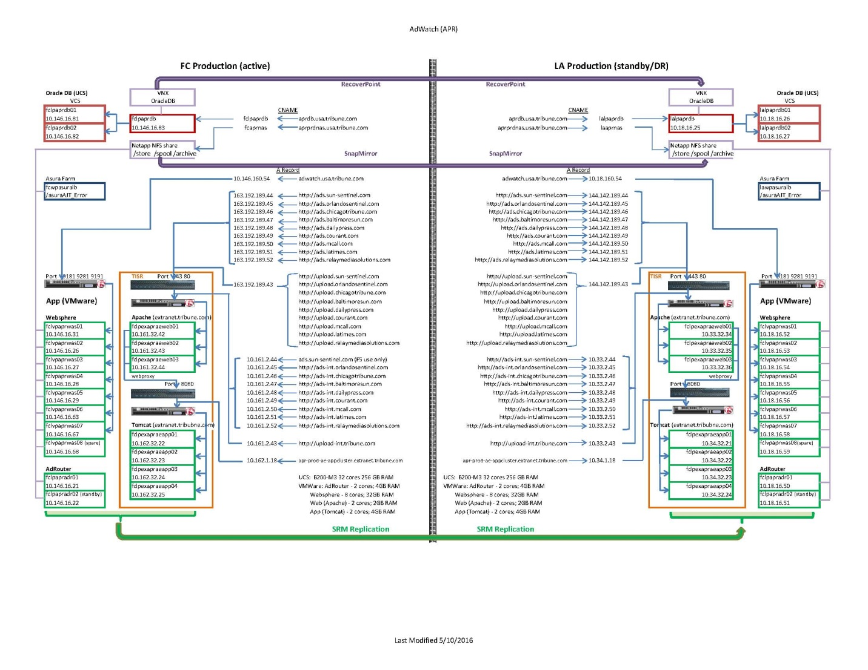

**AdWatch Disaster Recovery Objectives**

* The AdWatch Disaster Recovery plan provides a means to attain sustainability for the business by reducing the amount of downtime and potential revenue loss caused by a breakdown of the AdWatch application infrastructure. The primary objective is to recover quickly with minimal loss of data. These objectives are summarized as follows:
* Recovery Time Objective (RTO)
* This is the duration of time from which the business processes must be restored after a disaster (or disruption) in order to avoid unacceptable consequences associated with a break in business continuity. It is dictated by our Service Level Agreement (SLA) of which terms have been agreed upon by our business clients.
* AdWatch RTO Minimum = 15-30 minutes
* AdWatch RTO Maximum = 1 hour
* Recovery Point Objective (RPO)
* This is the maximum data loss that can be tolerated as the result of a major disruption or disaster scenario. It is dictated by our Service Level Agreement (SLA) of which terms have been agreed upon by our business clients.
* AdWatch RPO Minimum = 15 minutes
* AdWatch RPO Maximum = 30 minutes
* Note: These times may vary based on type of failure and point-in-time recovery if data corruption is suspected.

**AdWatch DR Scenarios**

**Controlled DR Failover (Annual Exercise)**

* By regularly testing DR we can ensure business continuity and be fully prepared to continue operations should a disaster occur.
  + The Run Book details the prep work required to initiate a Controlled Failover process
  + Includes a check list and procedural steps required to bring-up the environment at the Los Angeles DR site and Fail-back to its primary site.
  + Engagement of multiple Technology teams required

**DR Failover (Catastrophic Failure)**

* Sustained datacenter or application infrastructure failure exceeding RTO requirements. Production is unsustainable and there’s substantial risk missing press deadlines and possible revenue loss.
  + System is brought up in LA – Point in time recovery for database and NetApp file share may be required depending on the type of failure
  + 15-30 minute data loss is anticipated

**AdWatch DR Runbook and Checklist**

[**AdWatch DR Document Repository**](http://teams.tribune.com/technology/ops/AppSup/KB/Documents/Forms/AllItems.aspx?RootFolder=%2Ftechnology%2Fops%2FAppSup%2FKB%2FDocuments%2FDR%20Procedures%2FAdWatch&FolderCTID=0x0120002A1BA33A55F5204094FAFD964C6F48EB&View=%7bC6161C3D-8BCD-4655-AB0B-80F3F1FF8F96%7d)

* + 1. Environments

This section provides the environment details with respect to the AdWatch.

**Change management**

* Major upgrades and application changes performed on the Dev environment
* Upgrades and configuration changes are done on QA – System closely resembles production. For major upgrades we synch Prod to QA (AdWatch DB, FileShare)
* Prod upgrades or changes are managed via change management process. Requires Business and Technology approvals to proceed.

**Tickets**

* P1 – Escalated immediately. Typically used for a general outage where a major catastrophic issue has occurred and has exceeded the 30 minute downtime rule.
* P2 – We technically respond to those within 15 minutes and work towards a solution. Usually impacting individual or a Market. Typically missing ads, Preflight issues, unable to process an ad, unable to login.
* P3 – We triage the ticket and have at least a day to address it. Usually product setup requests or configuration changes – minor issues.
* P4 – These are tickets that will take 2-4 weeks to address. Condidered small project. Typically, configuration changes or product setups.

**Typical Tickets or error notifications:**

* Booking Errors – Cause by missing or incorrectly formatted Sales Rep ID, Products. Not in sync with Adit mapping.
* AdWatch not loading
* Preflight Failures (Asura)
* Setup Placements
* Translation Mappings Adit/AdWatch
* CR – AdRouter deployments
* CR – Upgrades
* CR – Data Dictionary upload – New site deployment

**Postgres Replication Serves-AdWatch**

|  |  |  |
| --- | --- | --- |
| **Host Name** | **User** | **Password** |
| Fclpentrepdb01.usa.tribune.com | Enterprisedb | Same as DSI |

|  |  |  |  |
| --- | --- | --- | --- |
| **UNIX script** | **Argument** | **Example** | **Description** |
| /etc/init.d/edb-xdbpubserver | stop | /etc/init.d/edb-xdbpubserver stop | Stop/kill pubserver process |
| /etc/init.d/edb-xdbpubserver | start | /etc/init.d/edb-xdbpubserver start | Start pubserver process |
| /etc/init.d/edb-xdbsubserver | stop | /etc/init.d/edb-xdbpubserver stop | Stop/kill subserver process |
| /etc/init.d/edb-xdbsubserver | start | /etc/init.d/edb-xdbpubserver start | Start subserver process |

* + 1. Development
* AdWatch Dev High level description

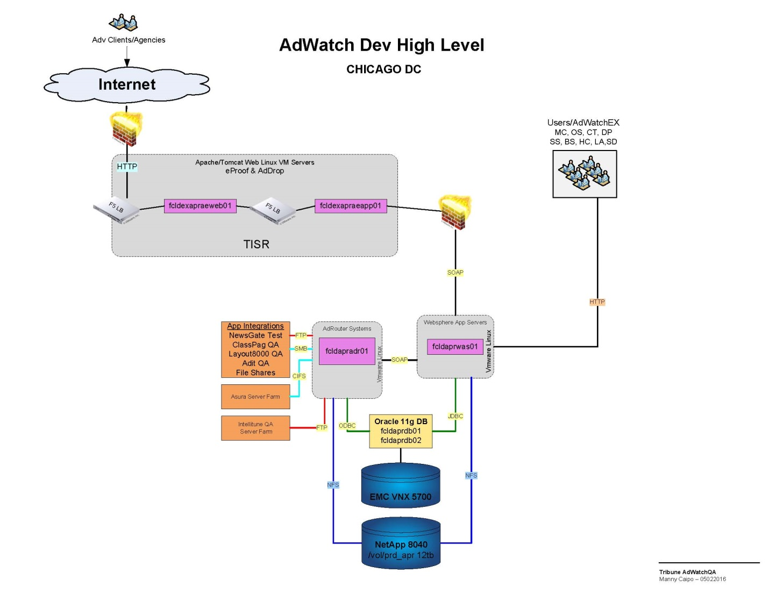

* + 1. Test
* AdWatch QA High level description

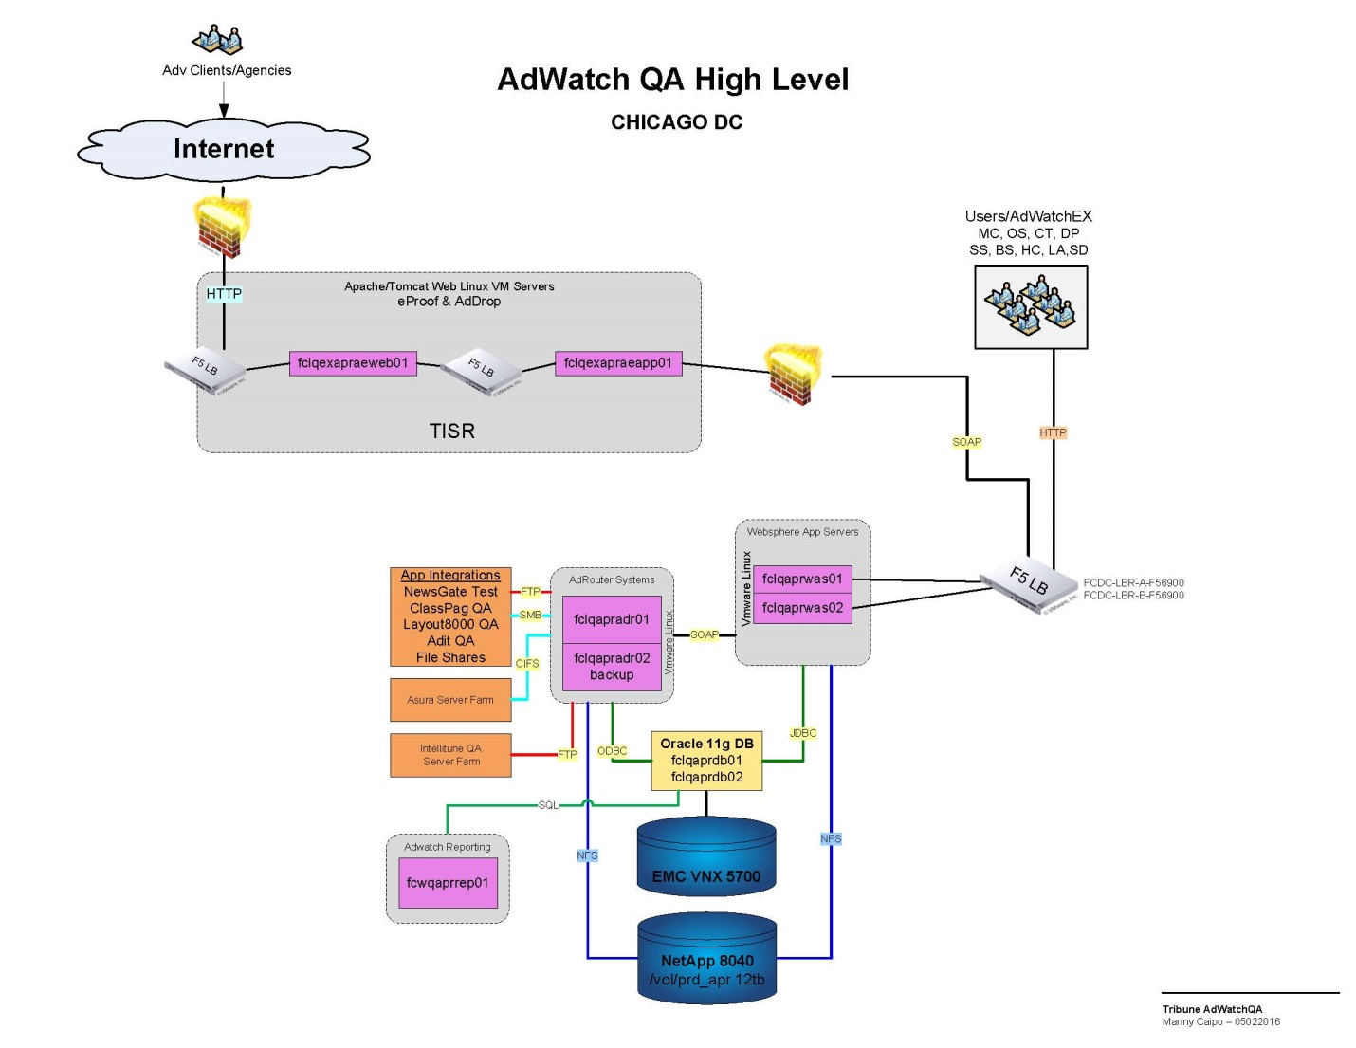

* + 1. User Acceptance Test

**AdWatch Validation Test Plan**

Purpose: This test plan is to be used by Frontend Support after an incident, patch or upgrade to verify the AdWatch system is up and running.

**OUTLINE OF THE TEST:**

|  |
| --- |
| * Access a Macintosh computer by VPN connection from your pc. |
| * Log into AdWatch and verify the following: |
| * Automatic emails for AdDrop |
| * Edit function |
| * Automatic email for eProofs |
| * Pickup with Changes workflow |
| * Eproof comment submission |
| * Straight Pickup workflow |
| * Electronic ad workflow |
| * Delivery to a pagination destination   **PRE-TEST TASKS:**   |  | | --- | | * The insertion date should be no more than a week out so that automatic pickup functionality wiil work. Please work on the first 3 in order. | | * First ad - Production method = Build | | * Second ad - Production method = Pickup Changes (pickup is first ad) | | * Third ad - Production method = Straight Pickup (straight pickup is second ad) | | * Fourth ad - Production method = Electronic | | * Note the Sales Rep name. You will need to change their email to your email address before you begin your testing. | |  | |

* + 1. Production
* AdWatch Production High level description.

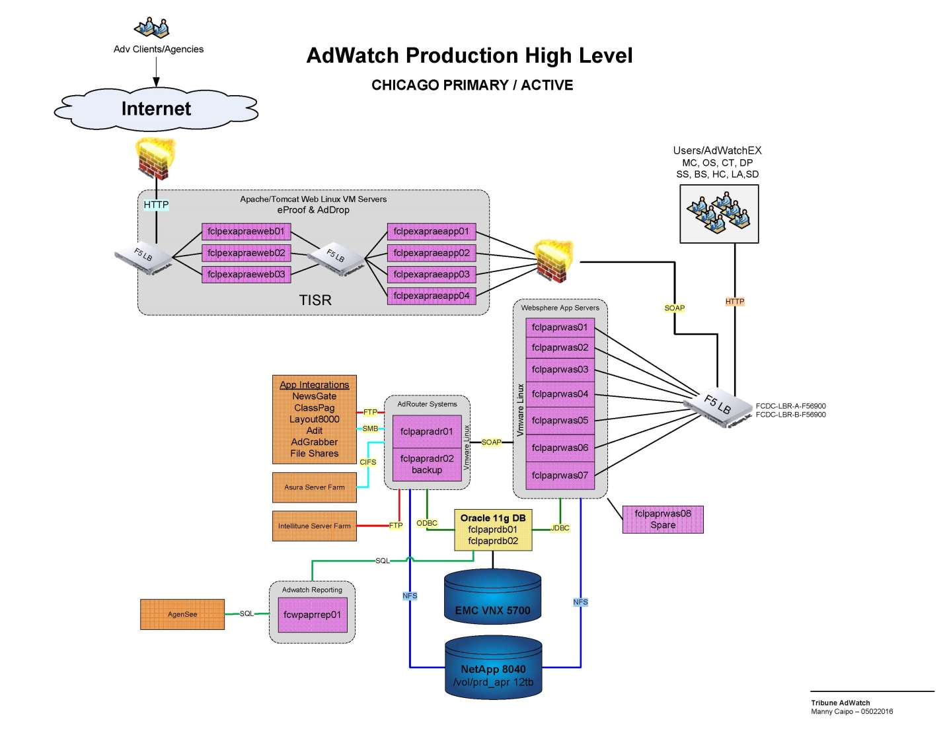

* 1. ClassPag
* Classpag is an application used to produce fully-paginated classified pages and partial classified blocks for publications. It gets information from frontend booking systems (Adit/Adss), and sends to Newsgate or directly to platemaking systems. The application vendor is Software Consulting Services (SCS).
* ClassPag is an application that paginates classified liners and display ads. These are typically Help Wanted, Employment, Automotive, Real Estate, Legal, Obits and other ads that are considered non-retail.

**Typical Users – Classified Paginators (AdOps/Production)**

* Paginators access the application using Xming-client via Citrix, or
* An icon on their desktop using Xming (backup/alternate method)
* Mac X11 (backup/alternate method).
  + 1. Business Process Flow
* Classified Liners and Display ads are ordered through Adit and Adss (Self Service).
* Bookings are delivered to Classpag as flat text sort files
* Adwatch delivers liner eps and Class display ad eps
* Liner and EPS ads are combined and categorized via sort file rules and paginated.
* Completed Class Blocks are exported and delivered to Newsgate pagination system into the ad pool. The block is treated as an ad. Note: booking comes from Layout 8000.
* Full pages exported directly to Arkitex or Page distribution system
* Application Components – 9 Linux VM Servers (1 per market), Citrix, NetApp
  + 1. Interfaces

**Maintenance**

* None needed. Application is only brought into maintenance for Linux patching or Classpag upgrades.
  + 1. Database
* ClassPag QA DR IP’s:

|  |  |
| --- | --- |
| **Server** | **IP address** |
| fclqscsapp01.usa.tribune.com | 10.18.31.27 |
| fclqscsapp02.usa.tribune.com | 10.18.31.28 |
| fclqscsapp03.usa.tribune.com | 10.18.31.29 |
| fclqscsapp04.usa.tribune.com | 10.18.31.30 |
| fclqscsapp05.usa.tribune.com | 10.18.31.31 |
| fclqscsapp06.usa.tribune.com | 10.18.31.32 |
| fclqscsapp07.usa.tribune.com | 10.18.31.33 |
| fclqscsapp08.usa.tribune.com | 10.18.31.34 |
| fclqscsapp09.usa.tribune.com | 10.18.31.53 |

* + 1. Dependencies
* The above diagram illustrates upstream and downstream dependencies for ClassPag.

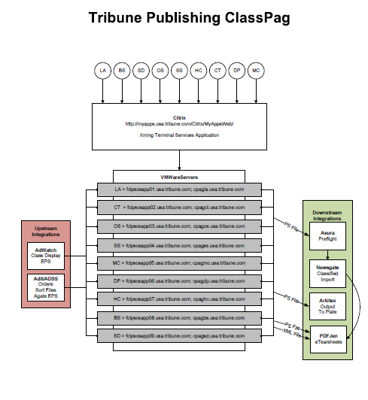

* + 1. Operating Assumptions
    2. Minimum Software Requirements
* ClassPag network can be accessed by Citrix 4.4.
  + 1. Minimum Hardware Requirements

**Orlando Sentinel**

3 Dell PowerEdge 2650 Servers  
 2 Processors (4 logical) Intel(R)Xeon 2.8 GHz - 4gb RAM  
 5 146gb Disk Drives  
  
**Ft. Lauderdale Sun-Sentinel**3 Dell PowerEdge 2800 Servers  
3.4G, 1M, XEON NOCONA  
5 146GB Disk Drives  
  
  
**Hartford Courant**Four servers: two production, two test.   
  
**Allentown Morning Call**Two Dell PowerEdge 2800 servers. One primary and one backup.  
  
**Newport News Daily Press**Two Dell PowerEdge 2850 servers, 2GB ram each (going to 4GB in Jan'09 to support ClassPag+Layout). Main is tagged 351DLB1, backup is tagged D58DLB1

* + 1. Inventory

*<Provide details about inventory location and VSS>*

* + 1. Security Requirements
    2. Environments

This section provides the environment details with respect to the ClassPag

**Tickets**

* P1 – Escalated immediately. Typically used for a general outage where a major catastrophic issue has occurred and has exceeded the 30 minute downtime rule.
* P2 – We technically respond to those within 15 minutes and work towards a solution. Usually impacting an individual or a Market. Typically missing ads, unable to export paginated page, unable to login.
* P3 – We triage the ticket and have at least a day to address it. Usually product setup requests or configuration changes – minor issues.
* P4 – These are tickets that will take 2-4 weeks to address. Considered small projects. Typically, configuration changes or product setups.

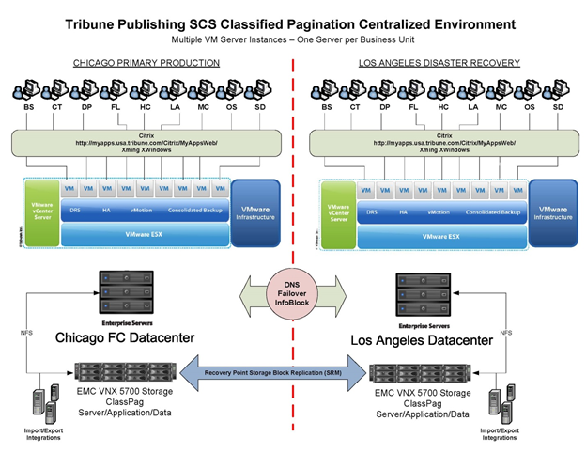

* + 1. Development

<Provide the link, IP, Architecture diagram, other details with respect to Development environment and the procedures to be followed for deploying in the Development environment.>

* + 1. Test

<Provide the link, IP, Architecture diagram, other supporting details with respect to Test environment and the procedures to be followed for deploying in the Test environment.>

* + 1. Test Scenarios

<Embed the test scenario document or provide the document link. In addition, specify the dos and don’ts to be considered while testing the application.>

* + 1. User Acceptance Test

<Provide the link, IP, Architecture diagram, other supporting details with respect to UAT environment and the procedures to be followed for deploying in the UAT environment.>

* + 1. Production

<Provide the procedures to be followed while deploying in the Production environment.>

* 1. Dynamics AX

Dynamics AX is Microsoft’s flagship ERP system. Tribune publishing uses this system as an account receivables system. Invoicing and billing are executed from this system.

**Key Technologies**

* Microsoft Dynamics AX 2009
* Microsoft SQL Server
  + 1. Business Process Flow
       1. Weekly invoicing
* Weekly invoicing jobs run for each business unit. These jobs are run concurrently, scheduled 1 minute apart.
* Weekly invoicing deadline is Monday midnight CST. Hence all invoicing jobs need to be completed by Sunday 11:50pm CST. All GL jobs run at 00:05 am on Monday.
* The below jobs needs to be completed before invoicing jobs are started. These jobs are highly required to be completed so as to ensure proper statement generation.
  1. Update invoice master Id
  2. Update sales table
  3. Update insertion order level
  4. Update invoice master Id2
  5. Update sales table2
  6. Update insertion order level2

Please refer the weekly invoicing playbook for step by step execution. (File name: *AX_5_2_Generate Weekly Statements*)

* + - 1. Weekly statements
* Weekly Statement generation jobs are distributed over 5 different servers depending upon grouping of customer criteria. Servers are called SMQ servers. Only users with admin privileges will have access to these servers.

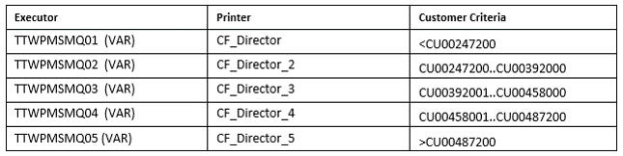

* Statements are run in TIC Company at all times.

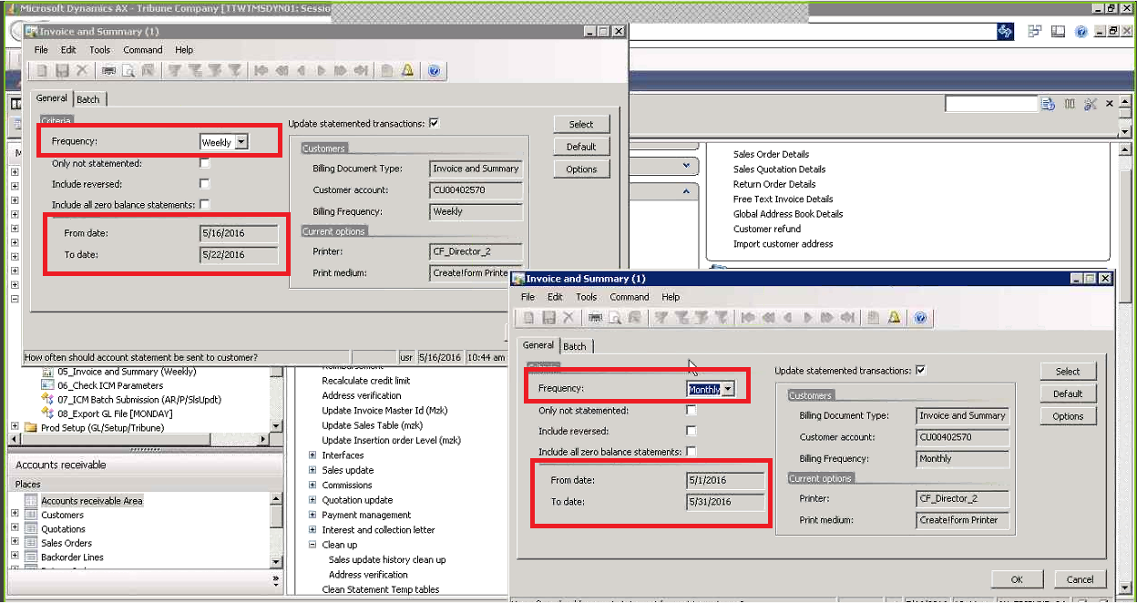

Please refer the weekly statement playbook for step by step execution. (File name: *AX_5_2_Generate Weekly Statements*)

* + - 1. DSM Firming Process
* DSM/DFP is a third party system which places orders for advertising online.
* Third party vendor called Placements extract the data from DSM and put it on Amazon S3 server every day.
* The DSM Adapter processes these files, formats them and places on a server which can be accessed by AX.
* There are 2 batch jobs of AX which read and process data from billing and forecast files.
* The ‘Import Current DSM orders’ runs at 5.44 am every day and takes up billing data.
* The ‘Import Future DSM orders’ takes up forecast data and runs at 6 pm every day.
* The firming of orders takes place as specified in DSM calendar.

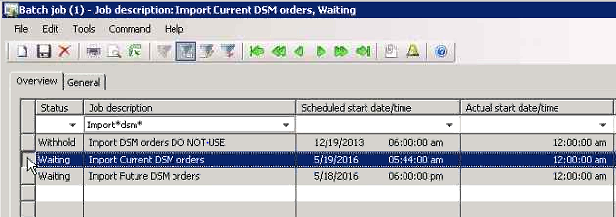

For details of executing firming process please refer following files:

*Period End Tasks SOP.xlsx*

*2016_DSM_Period_Calendar_FINAL.pdf*

*SQL DSM Recon.doc*

* + - 1. Dunning notices

Dunning notices are sent to the customer on 15th of every month. If 15th falls on a weekend, they must be processed on the next working day.

Dunning notices specify the amount due at the aging period of 30, 60, 90,120 days.

Dunning Notices are executed in the TIC company.

In AX navigate to: TIC >Account Receivable> Accounts Receivable Area> Reports> External> Statement- Dunning Notice

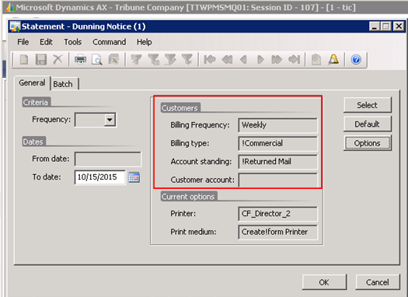

The following steps must followed in order to generate dunning notices:

1. Create and Post Petty Balance Journal: Run the Create and Post Petty Balance Journal located in the batch job scheduler
2. Run SQL Query Un-posted Transactions
3. Review Petty Balance Write-off Journals for Reasonableness.
4. Run Dunning Notices
5. Review and Send to Workflow One

For details steps, refer to *AX_5_5_Dunning Notices.docx*

* + - 1. Upload statements to Workflow One

Files need to be sent to Workflow One(Standard Register) on a weekly/monthly basis.

Following are the file types that should be sent to Work Flow One on a weekly/monthly basis.

1. Weekly statements :

TB7_YYYY-MM-DD_InvoiceSummary_Weekly_NONZERO_#########.zip

1. Monthly statements :

TB7_YYYY-MM-DD_InvoiceSummary_Monthly_NONZERO_#########.zip

1. Monthly dunning notices:

TB7_ YYYY-MM-DD_DUNN_ALLDUNN.zip

The following steps must be followed to upload the statement files to workflow one.

Open the project folder and find the non-zero group of files for the specific billing period.

* 1. There will be pst files and text files in this group.
  2. Reconcile all the files and check for their reasonableness.
  3. Check if the billing dates, billing period and formatting is proper on the files.
  4. Now copy the non-zero files from “Projects” folder to “Input” subfolder.
  5. Execute the FTP-Zip utility to compress the files and move them to “Outputs” folder. Confirm that they are compressed successfully.
  6. Open up the FileZilla application and upload all .ZIP statement files from the Output folder to the ftp site Incoming folder.
  7. Move the compressed files to Workflow one “Incoming” folder.
  8. Workflow One will send receipt of these files once they are sent.
  9. Send an email to [Sterling.Chapman@workflowone.com](mailto:Sterling.Chapman@workflowone.com) with a screen shot of all files
  10. Workflow one will now start processing all the sent files, and once this is complete they will send a remit report on the following day. Validate the remit file against the txt file total count.

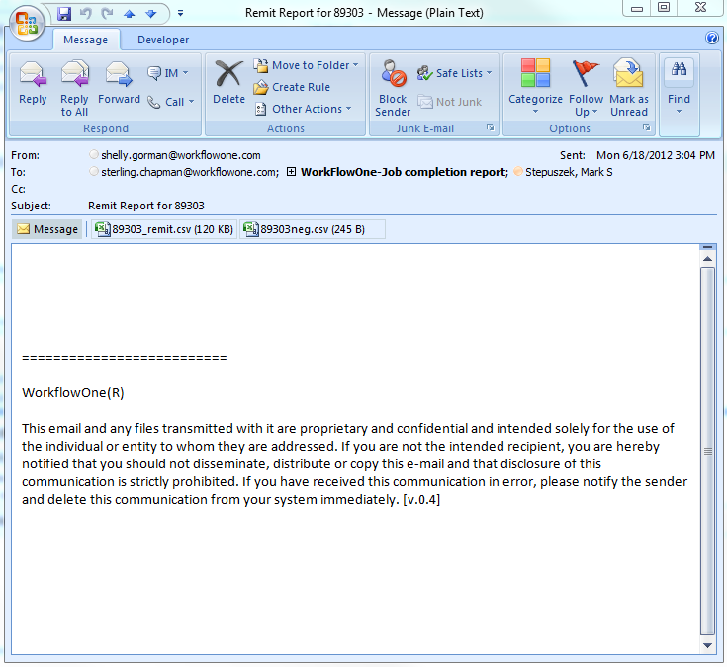

For detailed steps refer *AX_5_2_Standard Register.docx*

* + - 1. Upload files to Merlin One:

1. The weekly and monthly XML files must be sent to Merlin One for processing.
2. Navigate to the “Save” folder and locate the XML files for the billing period. Following will be the naming convention for the weekly and the monthly XML file.

*MZKCustInvoiceSummary;<USERID>;<Billing date>.xml*

1. There will be one XML file for each customer segment. Run the MerlinOne_Weekly job. Drag the XML files for specific billing period to MerlinOne.bat job. Observe the dialog box that shows the status of the process.

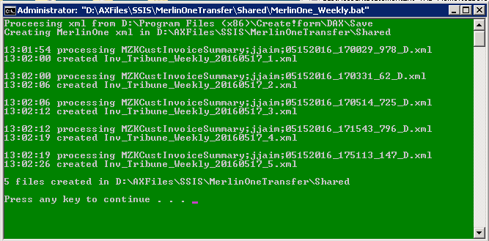

1. Access the MerlinOne ftp site, move the current billing files to merlin one invoice folder
2. Send an email to [esheets-support@merlinone.com](mailto:esheets-support@merlinone.com) advising them that the files have been sent to the MerlinOne FTP server. Include the total number of statements created.

For detailed steps refer *AX_5_12_Weekly_monthly Tribune files sent to MerlinOne.docx.*

* + 1. Interfaces
       1. Customer setup for invoicing

The following setups are invoice related setups for customer master.

* Billing type:

Path: Go to **customer details**-> open **customer** -> **Header**- > **Tribune** tab -> **internal** **classification** ->**Billing type**

Values available in billing type are:

1. Commercial : These are commercial customers which are generally for monthly customers
2. Value pre-paid: customer has a credit limit set to it. So the ad amount is deducted from the credit
3. Private party : individuals who want to advertise like doctors
4. Intercompany : Not using this option
5. House : internal ads which business units might want to setup

* Billing frequency:

It indicates the frequency at which the customer needs to be billed (statement sent)

Path: Go to **customer details**-> open **customer** -> **Header**- > **Tribune** tab ->**Customer invoice and statement** -> **Billing frequency**

Values available are

1. Weekly
2. Monthly

* Condensed/ non-condensed

Path: Go to **customer details**-> open **customer** -> **Header**- >**General**->**Customer information**->**Condensed**

When the condensed indicator is checked, it will combine the sales line into one line and line amount will be added up on the statement. When un-ticked, it will be kept as separate lines hence statement will be itemized.

* + 1. Databases

|  |  |  |  |
| --- | --- | --- | --- |
| **Database Name** | **Schema Name** | **Table Name** | **Description** |

* + 1. Dependencies

<Provide details of dependencies that are to be considered for configuring the application.>

* + 1. Operating Assumptions
    2. Minimum Hardware Requirements
    3. Inventory

*<Provide details about inventory location and VSS>*

* + 1. Security Requirements

<Provide details on Data Handling of security measures.>

* + 1. Environments

This section provides the environment details with respect to the <Application Name>.

* + 1. Development

<Provide the link, IP, Architecture diagram, other details with respect to Development environment and the procedures to be followed for deploying in the Development environment.>

* + 1. Test

<Provide the link, IP, Architecture diagram, other supporting details with respect to Test environment and the procedures to be followed for deploying in the Test environment.>

* + 1. Test Scenarios

<Embed the test scenario document or provide the document link. In addition, specify the dos and don’ts to be considered while testing the application.>

* + 1. User Acceptance Test

<Provide the link, IP, Architecture diagram, other supporting details with respect to UAT environment and the procedures to be followed for deploying in the UAT environment.>

* + 1. Production

<Provide the procedures to be followed while deploying in the Production environment.>

1. Common Tasks

<Provide details about the BAU activities that are being carried out by the application team in this section.

This section lists some of the generic day-to-day activities that are carried out for <Application Name>.

* 1. Monitoring and Management Activities

<Specify the Monitoring parameters and the activities to be performed as part of Monitoring.>

* + 1. Monitoring Tools

<Provide the Monitoring tools that are used in the environment.>

* + 1. Critical Jobs / Integration needs / Schedules

< Provide the Critical Jobs, Schedules and Integration needs.>

* 1. Standard Maintenance Activities

<Specify the maintenance plan, frequency of maintenance, procedures to be followed for the maintenance activities with respect to the tower/team.>

* 1. Application License Management (Optional)

<Specify the license details of the Tools used by the tower.>

* + 1. License Requirements

<Specify the license requirements.>

* 1. Backup, Recovery, and Archival

<Provide details on Backup schedule, recovery, and archival.>

1. Reporting

This section specifies the list of reports that are being shared with the Customer and also provides details on the reporting template, frequency, and so on.

* 1. List of Reports

<Provide details of reports that need to be published and their frequency. Provide details on how these reports are presented to the Management and the tools used to report it.>

The following table lists the report details:

Table 4: Reports and their Frequencies

| Report Name | Report Frequency | Report Distribution List |
| --- | --- | --- |
| <Report 1> | Bi-Weekly | <Name 1>, <Name 2> |
| <Report 2> | Monthly | <Name 1>, <Name 2> |

* 1. Report Templates

<Provide templates for each report that is listed in the previous section 9.1: List of Reports. Provide details on how these reports are presented to the Management and the tools used to report it.>

1. Support Processes

<Provide an introduction to the processes involved in one or two paragraphs. Include a high-level overview of each of the processes as a diagrammatic representation within the sub-headings.

Some of the processes may not be applicable for Application. Hence specify ‘Not Applicable’ within the respective process sections.>

* 1. Asset and Configuration Management

<Attach the Process Document for Asset Management, if available. Provide additional details on the specific parameters that need to be maintained in Asset Management.>

RACI Matrix

<Provide detail in a table format as below. Specify the activity and the corresponding RACI matrix.>

<Sample text>

| Sl. No. | Primary Activities | TCS Entity 1 | TCS Entity 2 | Customer | Vendor |
| --- | --- | --- | --- | --- | --- |
| 1 | Installing an application | RA |  | C | I |

* 1. Incident Management

<Attach the Process Document for Incident Management, if available. Also map the end-to-end process with respect to the tower/team. Include the tool(s) that will be used while executing this procedure.>

RACI Matrix

<Provide details in the following table. Specify the activities and their corresponding RACI matrix.>

<Sample text>

| Sl. No. | Primary Activities | TCS Entity 1 | TCS Entity 2 | Customer | Vendor |
| --- | --- | --- | --- | --- | --- |
| 1 | Installing a server | RA |  | C | I |

* 1. Major Incident Management

<Attach the Process Document for Major Incident Management. Also map the end-to-end process with respect to the tower/team. Include the tool(s) that will be used while executing this process. Also include responsibilities of specific roles such as Incident Manager in the RACI.>

RACI Matrix

<Provide details in the following table. Specify the activities and their corresponding RACI matrix.>

<Sample text>

| Sl. No. | Primary Activities | TCS Entity 1 | TCS Entity 2 | Customer | Vendor |
| --- | --- | --- | --- | --- | --- |
| 1 | Installing a server | RA |  | C | I |

* 1. Service Request Management

<Attach the Process Document for Service Request Management. Also map the end-to-end process with respect to the tower/team. Include the tool(s) that will be used while executing this procedure. Also include the roles that correspond to Service Request Management Process in the RACI matrix.>

RACI Matrix

<Provide details in the following table. Specify the activities and their corresponding RACI matrix.>

<Sample text>

| Sl. No. | Primary Activities | TCS Entity 1 | TCS Entity 2 | Customer | Vendor |
| --- | --- | --- | --- | --- | --- |
| 1 | Installing a server | RA |  | C | I |

* 1. Problem Management

<Attach the Process Document for Problem Management. Also map the end-to-end process with respect to the tower/team. Include the tool(s) that will be used while executing this procedure. Also include the roles that correspond to Problem Management Process in the RACI matrix.>

RACI Matrix

<Provide details in the following table. Specify the activities and their corresponding RACI matrix.>

<Sample text>

| Sl. No. | Primary Activities | TCS Entity 1 | TCS Entity 2 | Customer | Vendor |
| --- | --- | --- | --- | --- | --- |
| 1 | Installing a server | RA |  | C | I |

* 1. Change Management

<Attach the Process Document for Change Management. Also map the end-to-end process with respect to the tower/team. Include the tool(s) that will be used while executing this procedure. Also include the roles that correspond to Change Management Process in the RACI matrix.>

RACI Matrix

<Provide details in the following table. Specify the activities and their corresponding RACI matrix.>

<Sample text>

| Sl. No. | Primary Activities | TCS Entity 1 | TCS Entity 2 | Customer | Vendor |
| --- | --- | --- | --- | --- | --- |
| 1 | Installing a server | RA |  | C | I |

* 1. Capacity and Availability Management

<Attach the Process Document for Capacity and Availability Management. Also map the end-to-end process with respect to the tower/team. Include the tool(s) that will be used while executing this procedure. Also include the roles that correspond to Capacity and Availability Management Process in the RACI matrix.>

RACI Matrix

<Provide details in the following table. Specify the activities and their corresponding RACI matrix.>

<Sample text>

| Sl. No. | Primary Activities | TCS Entity 1 | TCS Entity 2 | Customer | Vendor |
| --- | --- | --- | --- | --- | --- |
| 1 | Installing a server | RA |  | C | I |

* 1. Event Management

<Attach the Process Document for Event Management. Also map the end-to-end process with respect to the tower/team. Include the tool(s) that will be used while executing this procedure. Also include the roles that correspond to Event Management Process in the RACI. >

RACI Matrix

<Provide details in the following table. Specify the activities and their corresponding RACI matrix.>

<Sample text>

| Sl. No. | Primary Activities | TCS Entity 1 | TCS Entity 2 | Customer | Vendor |
| --- | --- | --- | --- | --- | --- |
| 1 | Installing a server | RA |  | C | I |

* 1. Project & Portfolio Management

<Attach the Process Document for Project & Portfolio Management. Also map the end-to-end process with respect to the tower/team. Also include the roles that correspond to Project & Portfolio Management Process in the RACI matrix>

RACI Matrix

<Provide details in the following table. Specify the activities and their corresponding RACI matrix.>

<Sample text>

| Sl. No. | Primary Activities | TCS Entity 1 | TCS Entity 2 | Customer | Vendor |
| --- | --- | --- | --- | --- | --- |
| 1 | Installing a server | RA |  | C | I |

* 1. ID & Access Management

<Attach the Process Document for ID & Access Management. Also map the end-to-end process with respect to the tower/ technology. Include the tool(s) for receiving the service request. Also include the roles that correspond to ID & Access Management Process in the RACI matrix.>

RACI Matrix

<Provide details in the following table. Specify the activities and their corresponding RACI matrix.>

<Sample text>

| Sl. No. | Primary Activities | TCS Entity 1 | TCS Entity 2 | Customer | Vendor |
| --- | --- | --- | --- | --- | --- |
| 1 | Installing a server | RA |  | C | I |

* 1. Knowledge Management

<Attach the Process Document for Knowledge Management. Also map the end-to-end process with respect to the tower/team. Include the tool(s)/document repository for receiving the service request. Also include the roles that correspond to Knowledge Management in the RACI matrix.>

RACI Matrix

<Provide details in the following table. Specify the activities and their corresponding RACI matrix.>

<Sample text>

| Sl. No. | Primary Activities | TCS Entity 1 | TCS Entity 2 | Customer | Vendor |
| --- | --- | --- | --- | --- | --- |
| 1 | Installing a server | RA |  | C | I |

* 1. Release Management

<Attach the Process Document for Release Management. Also map the end-to-end process with respect to the tower/team. Include the tool(s) for receiving the service request. Also include the roles that correspond to Release Management in the RACI matrix.>

RACI Matrix

<Provide details in the following table. Specify the activities and their corresponding RACI matrix.>

<Sample text>

| Sl. No. | Primary Activities | TCS Entity 1 | TCS Entity 2 | Customer | Vendor |
| --- | --- | --- | --- | --- | --- |
| 1 | Installing a server | RA |  | C | I |

* 1. Service Desk

<Attach the Process Document for Service Desk Management. Also map the end-to-end process with respect to the tower/team. Include Service Desk contact numbers and tools used for this service.>

RACI Matrix

<Provide details in the following table. Specify the activities and their corresponding RACI matrix.>

<Sample text>

| Sl. No. | Primary Activities | TCS Entity 1 | TCS Entity 2 | Customer | Vendor |
| --- | --- | --- | --- | --- | --- |
| 1 | Installing a server | RA |  | C | I |

1. TCS Organization Chart & Contact list

This section gives the TCS organization chart and the contact details of TCS associates supporting Application.

* 1. Organization Chart

<Provide the Organization Chart of TCS or reference link to Wiki.>

* 1. Contact List

<Provide the contact list of TCS associates or reverence link to Wiki.>

1. Tribune Support team Org Chart & Contact list

This section gives the Client organization chart and the contact details of Client associates supporting application

* 1. Organization Chart

<Provide the Organization Chart of Client or reference link to Wiki.>

* 1. Contact List

<Provide the contact list of Client or reference link to Wiki.>

1. Vendor/Partner Details & Contact List

This section provides information on the third-party vendors and partners applicable for <Application Name>.

* 1. Vendor/Partner Details

<Provide details of vendors in the following table or reference to Wiki. >

| Sl. No. | Vendor Name | Support Scope | Contract Period (dd-mmm-yy to dd-mmm-yy) | 1st Level Contact | Reference <provide link to contract> |
| --- | --- | --- | --- | --- | --- |
|  |  |  |  |  |  |

* 1. Contact List

<Provide contacts of the Vendor Support team for each vendor or reference to Wiki.>

* 1. Vendor Management Process

<Include the tasks performed to manage the vendors. Include the SLAs that need to be met for the required service levels, if any.>

RACI Matrix

<Provide details in the following table. Specify the activities and their corresponding RACI matrix.>

| Sl. No. | Primary Activities | TCS Entity 1 | TCS Entity 2 | Customer | Vendor |
| --- | --- | --- | --- | --- | --- |
|  |  |  |  |  |  |

* 1. Vendor Escalation Service Levels

<Provide a matrix for escalation of issues, where there is an OLA/ SLA for the vendors to meet the required service levels.>

<Sample text>

| Service Level | Hrs | Level 1 | Level 2 | Level 3 | Level 4 |
| --- | --- | --- | --- | --- | --- |
| S1 | 4.00 | 0.30 | 1.00 | 2.00 | 3.00 |
| S2 | 8.00 | 1.00 | 3.00 | 5.00 | 6.00 |
| S3 | 24.00 | 4.00 | 8.00 | 12.00 | 18.00 |
| S4 | 48.00 | 10.00 | 15.00 | 24.00 | 32.00 |

* 1. Vendor Escalation Matrix

<Define the vendor contract details of different levels of contract for escalating issues.>

1. Documents Obtained from <Client Name>

<Provide the location/repository details of all the documents gathered from <Client Name>.>

1. Business Continuity Plan

<Provide the location of the BCP Plan. Mention the type of DR site (Hot/Warm/Cold). Also mention the service levels to Customer in case of BCP. In case it is included as part of the Enterprise Overview template you may refer to the same here.>

Appendix

<In this section, provide any additional information or reference documents such as Job Aids, Forms, Checklists, Templates required to execute the procedures.>

Before sending this document to the Customer, please ensure that you have deleted all Guideline Texts (displayed in Green and blue) and Callouts from the document.